**Operating System**

**CSL303**

**Lab Workbook**



**Faculty Name: Dr. Asha Sohal Student name: Nishant Rajora**

**Roll No.: 23csu220**

**Semester: 5**

**Group: DS-A**

Department of Computer Science and Engineering The NorthCap University

Gurugram- 122017, India

Session 2025-26

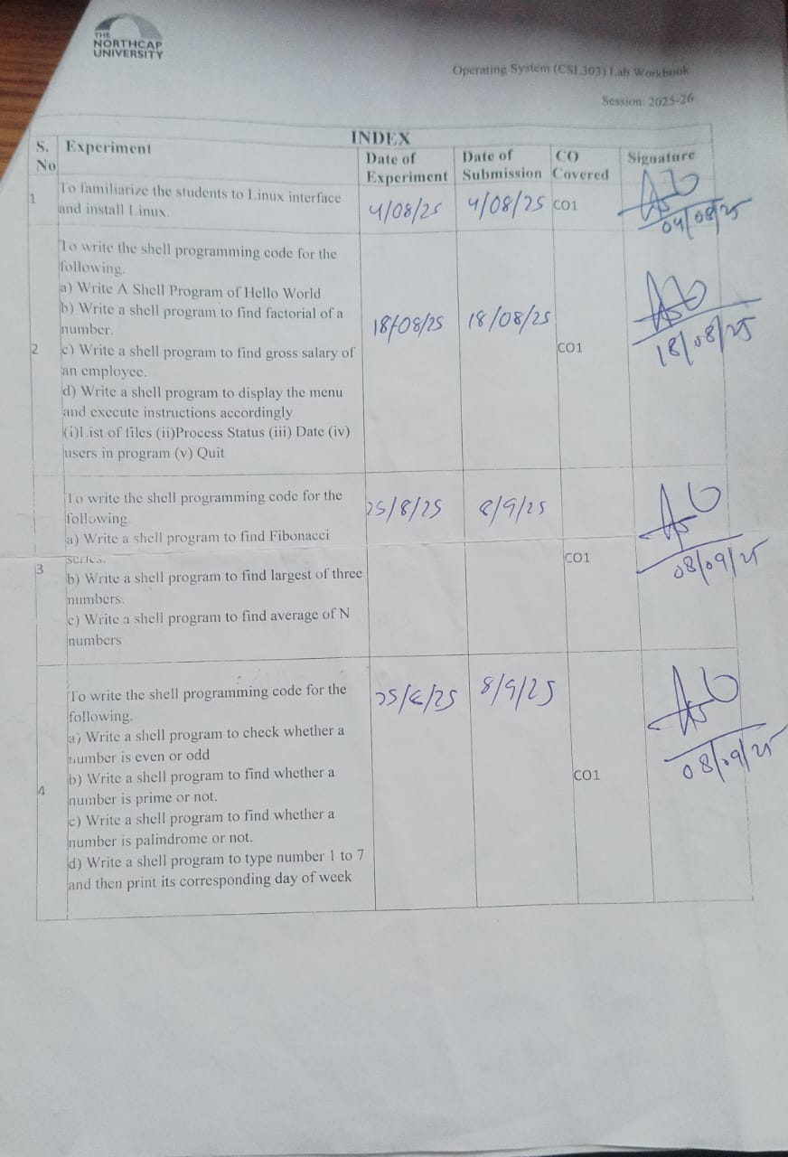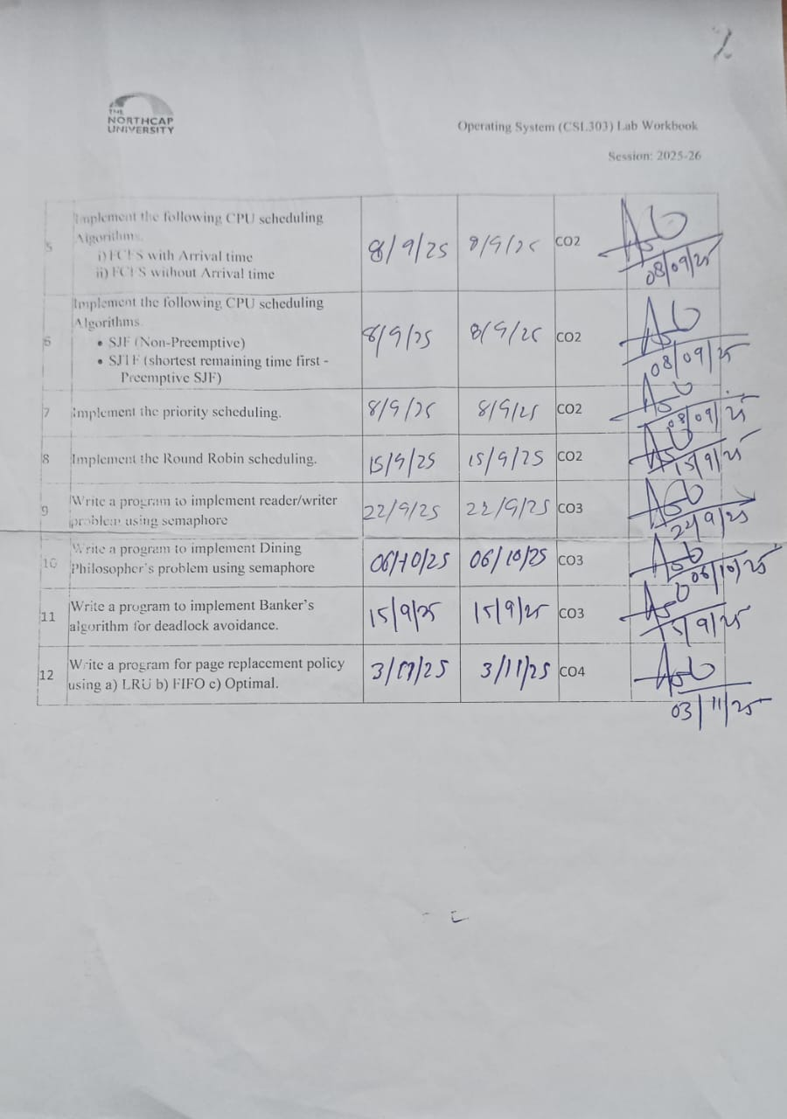

**Experiment No: 1**

|  |
| --- |
| **Student Name and Roll Number: Nishant Rajora 23csu220** |
| **Semester /Section: 5th DS-A** |
| **Link to Code:** |
| **Date: 04/08/2025** |
| **Faculty Signature: Dr. Asha Sohal** |
| **Marks:** |

|  |
| --- |
| **Objective(s):**  To familiarize the students to Linux interface. |
| **Outcome:**   * The students will understand commands used in Linux. |
| **Problem Statement:**  Implement the following things:   * Linux Installation |
| **Background Study:**  Cygwin is a open source tool which provides that functionality of the Linux in windows Operating System. Cygwin is a large collection of GNU and Open Source tools which provide functionality similar to a Linux distribution on Windows. It is a DLL (cygwin1.dll) which provides substantial POSIX API functionality. |
| **Question Bank:**  1. What is Linux? **Linux is an open-source Unix-like operating system kernel used in various distributions.**  2. How will you List files from a directory? **ls**  3. How files in a directory can be removed? **rm filename**  4. How to find out a word in a file? **grep 'word' filename**  5. What are wildcards? **Wildcards are special characters used to match file or directory names. Common wildcards: * – Matches any number of characters ? – Matches a single character [] – Matches any one of the characters enclosed** |

**Student Work Area**

**Algorithm/Flowchart/Code/Sample Outputs**

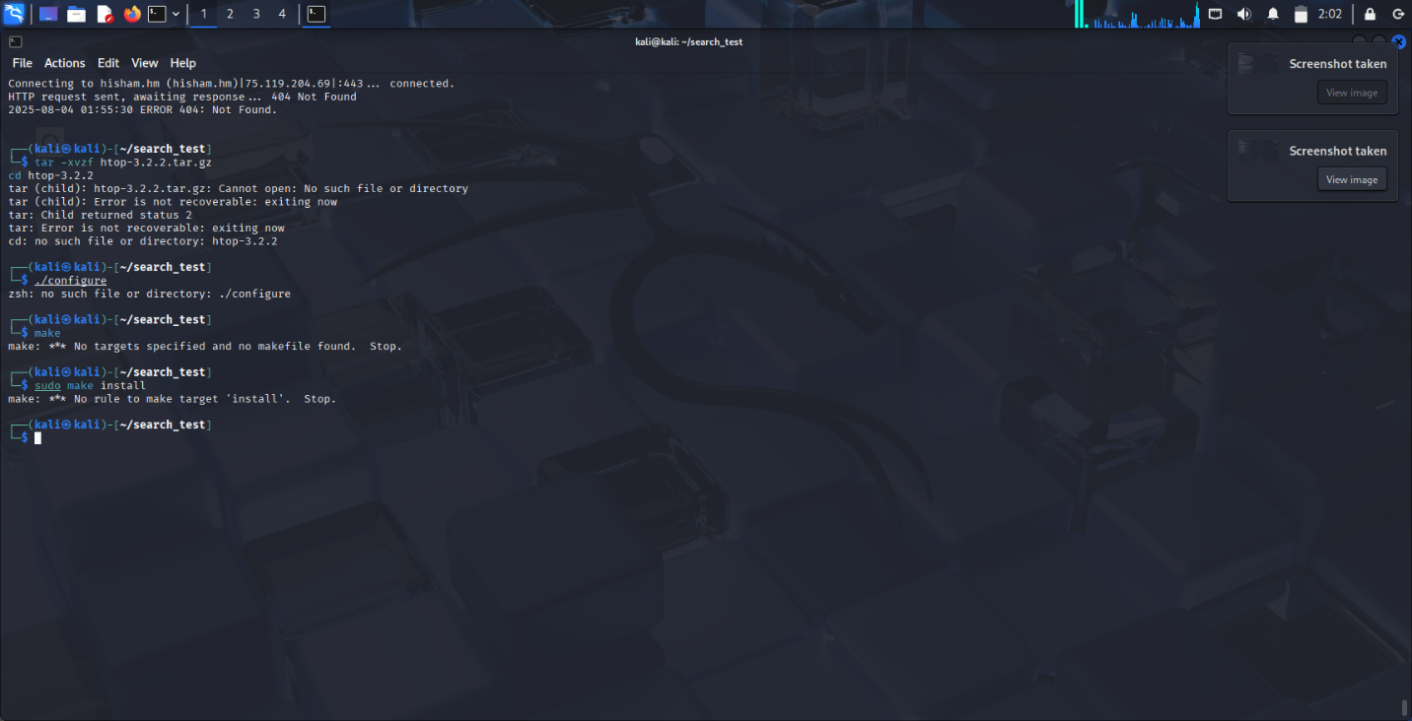

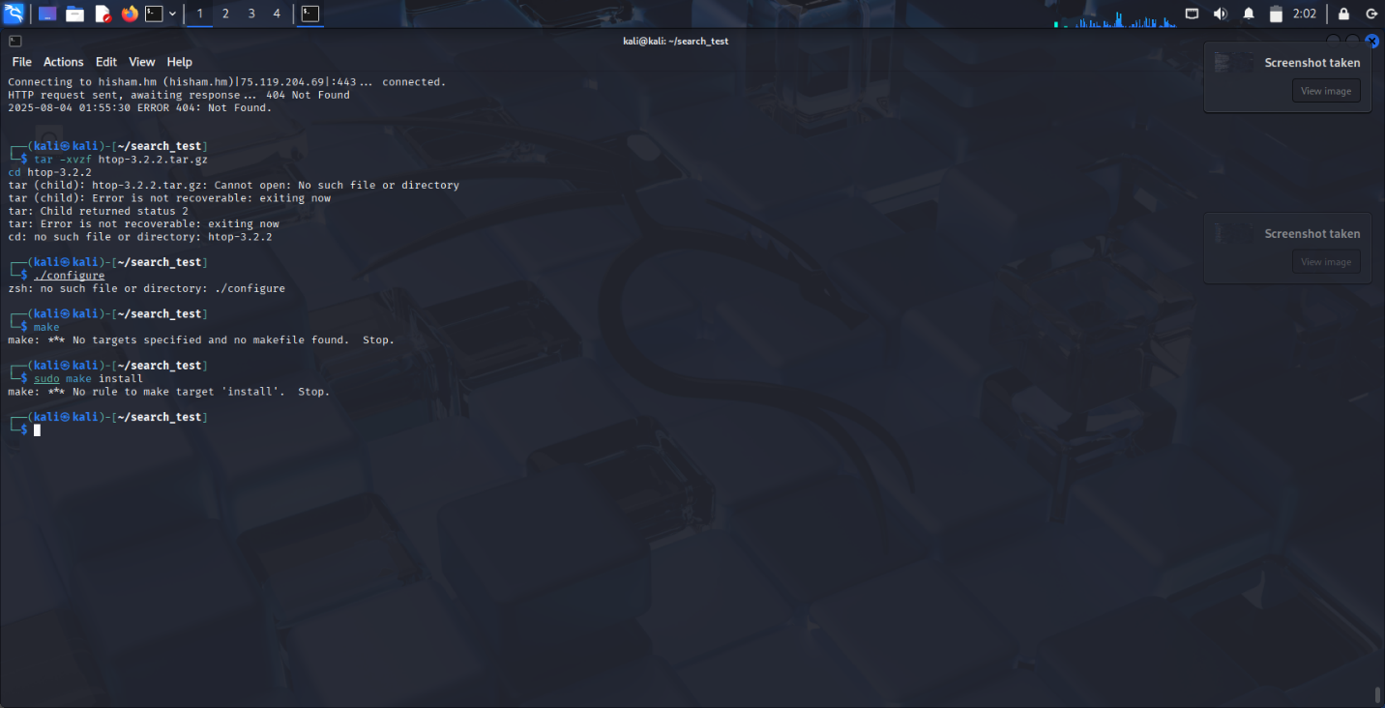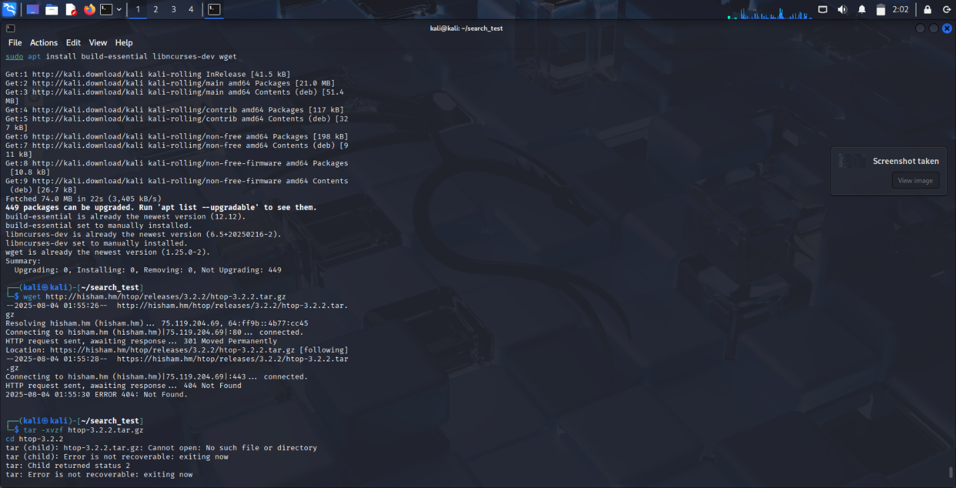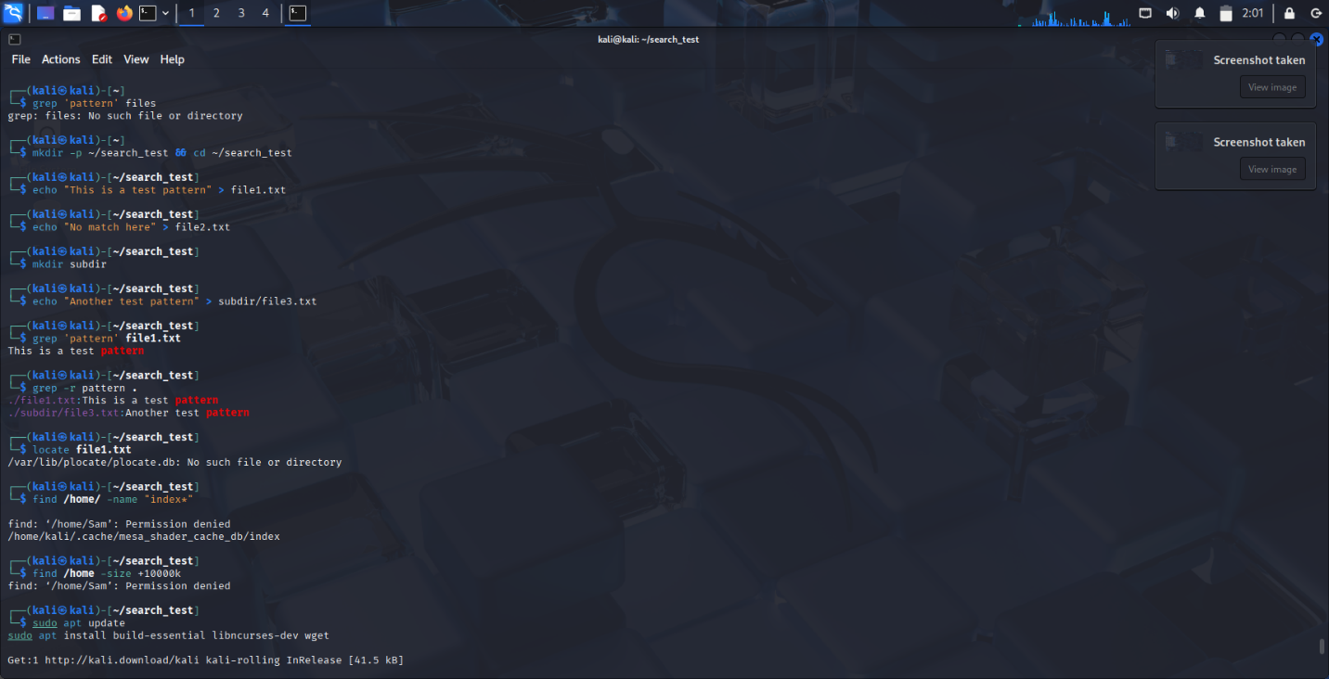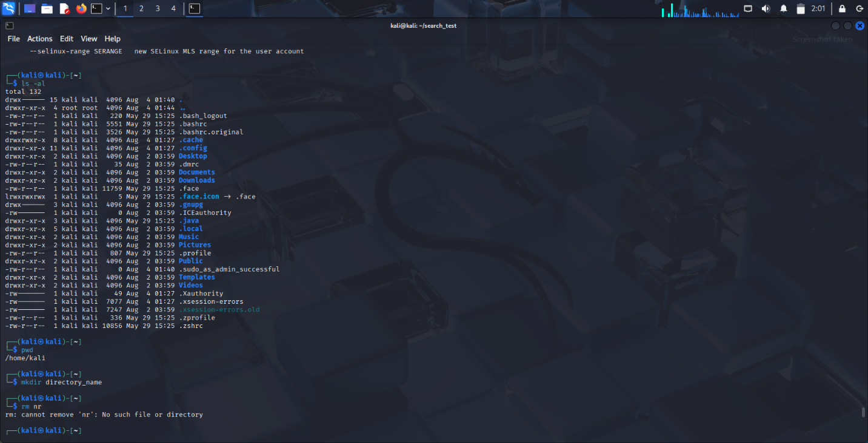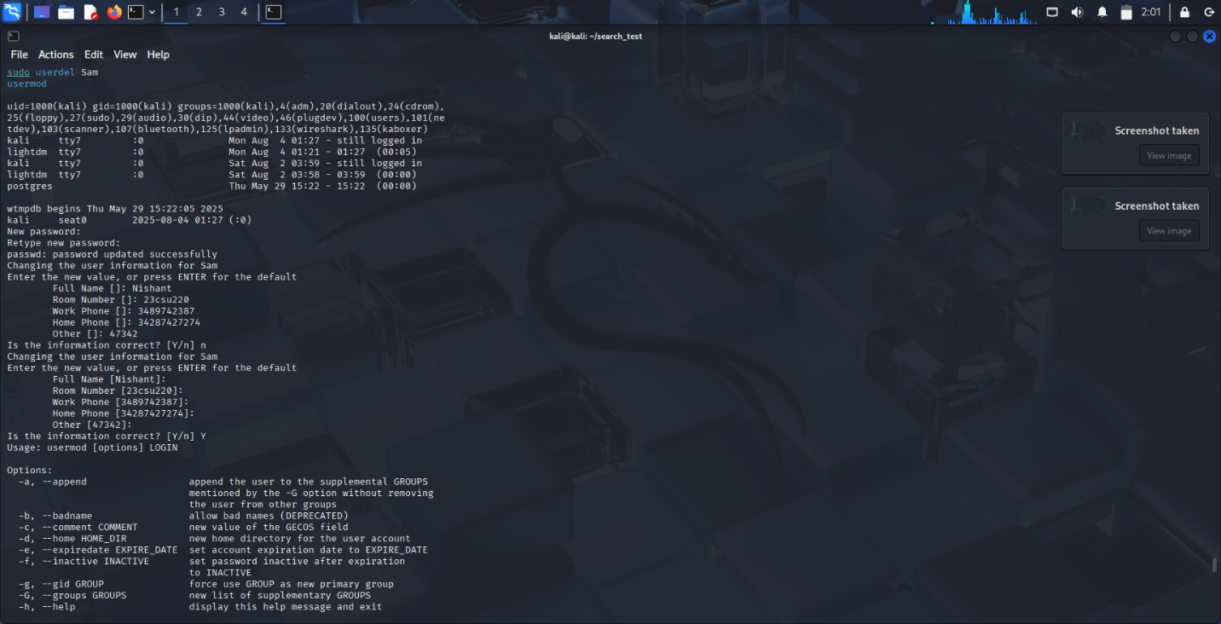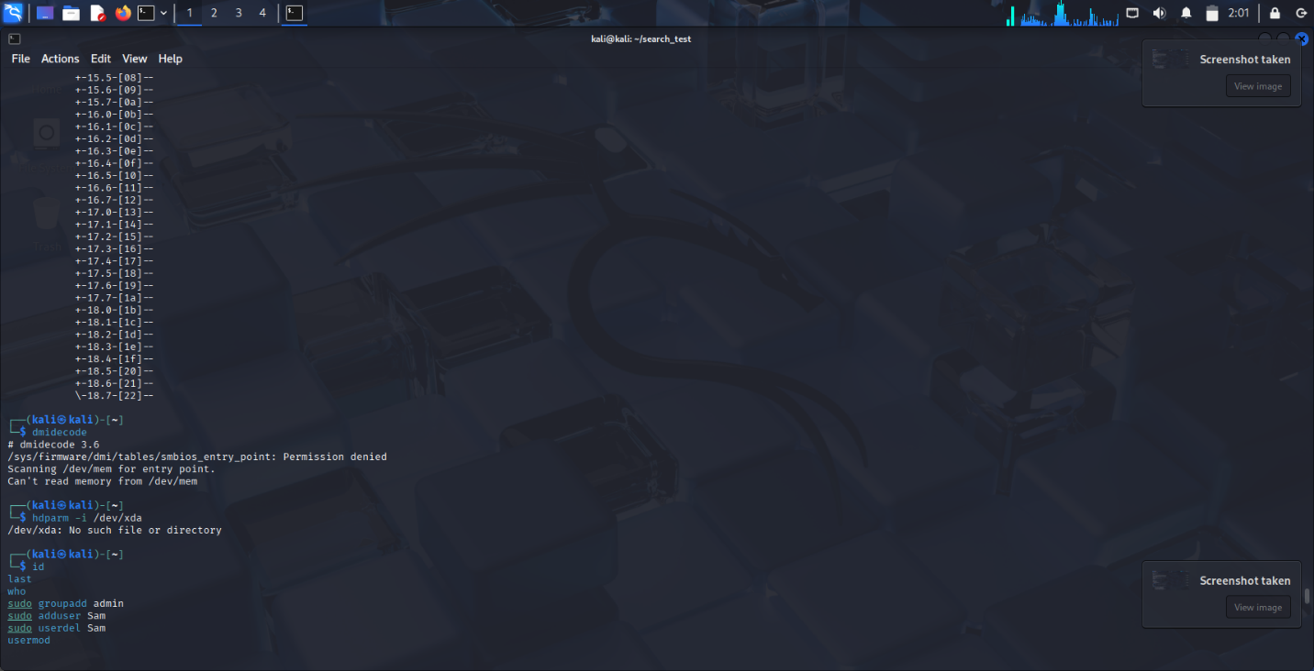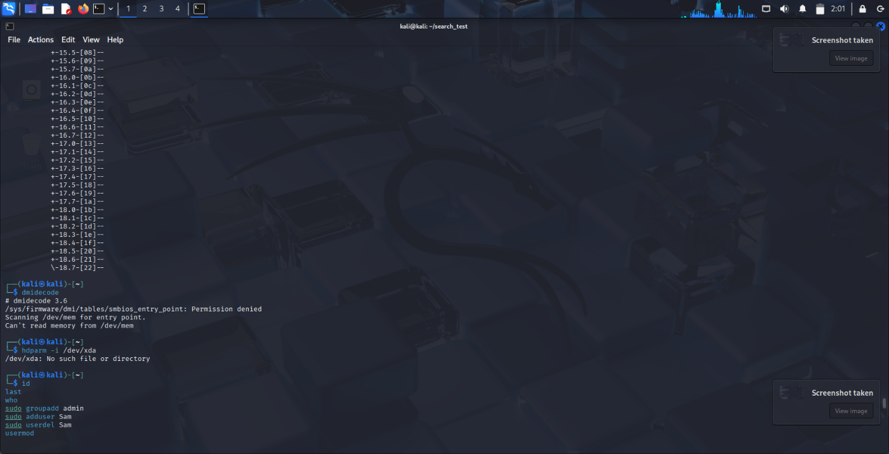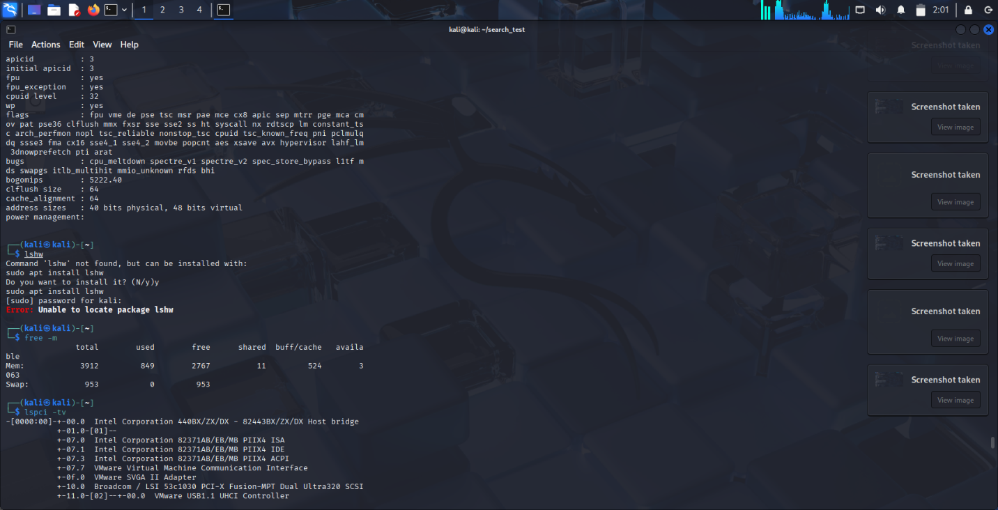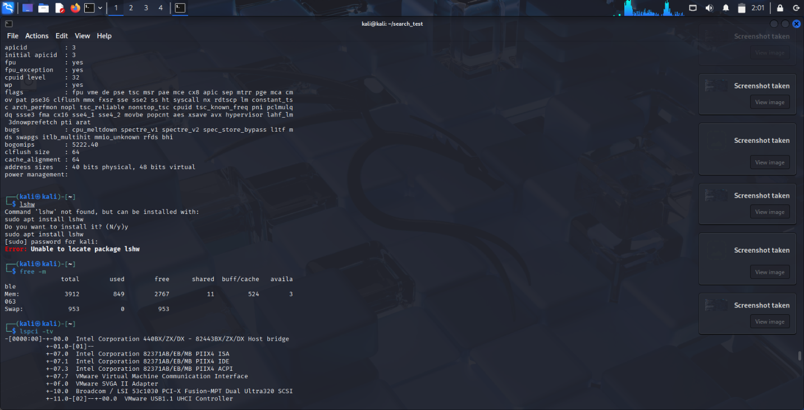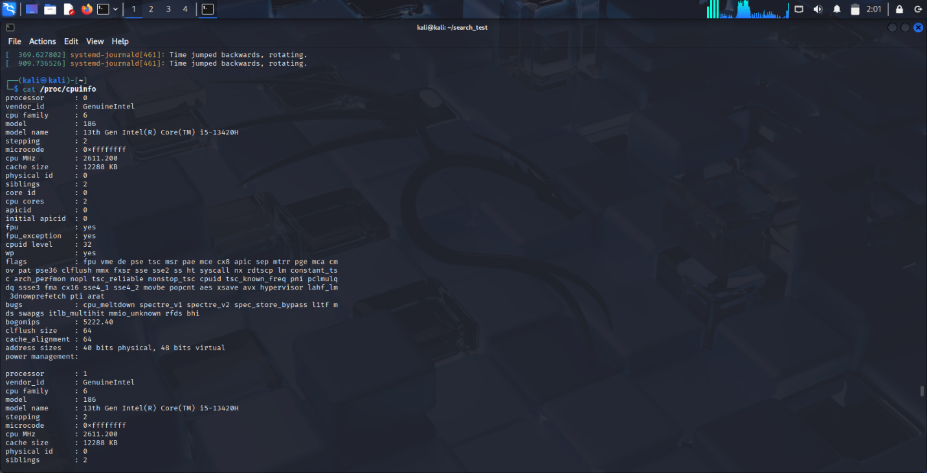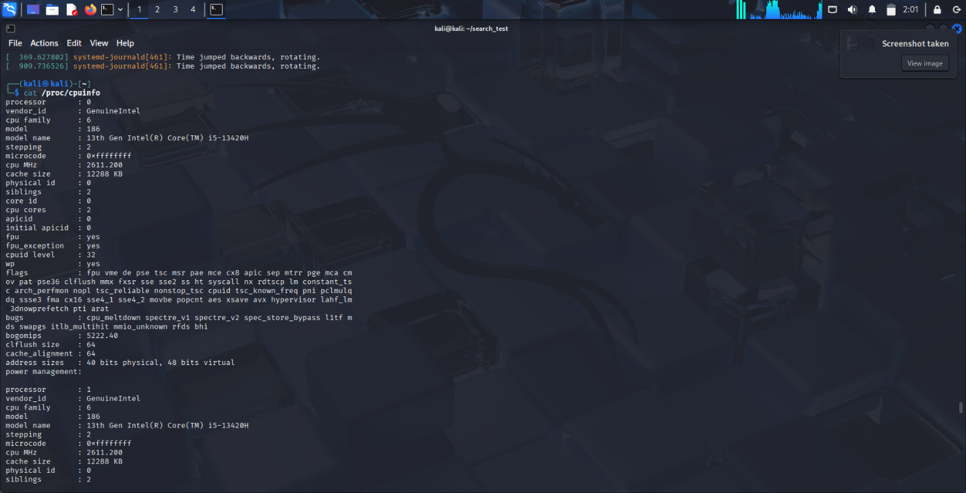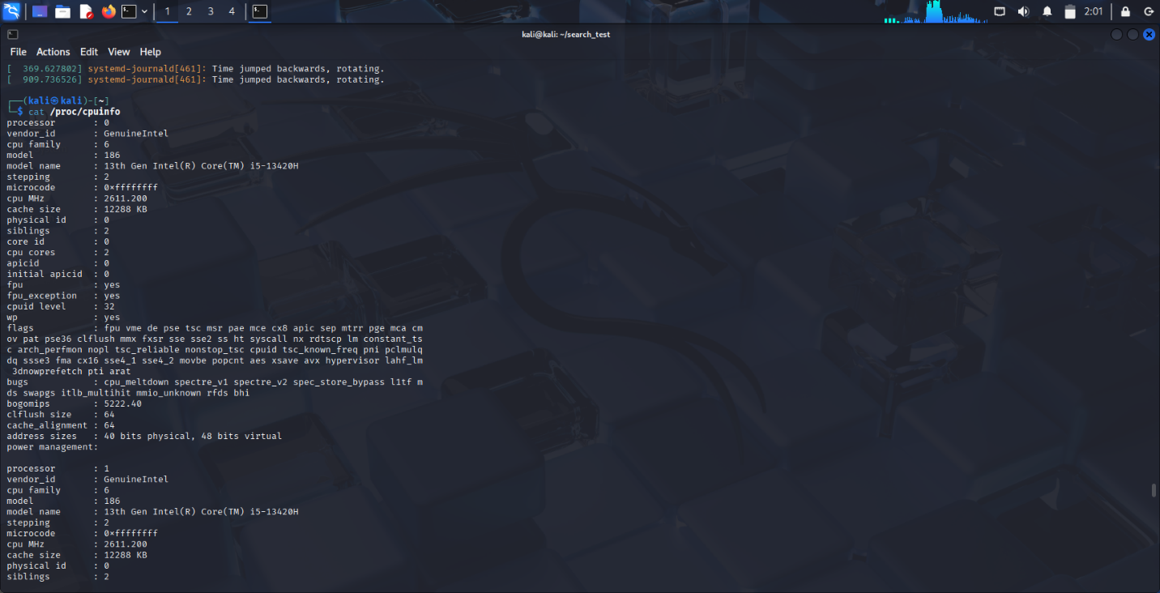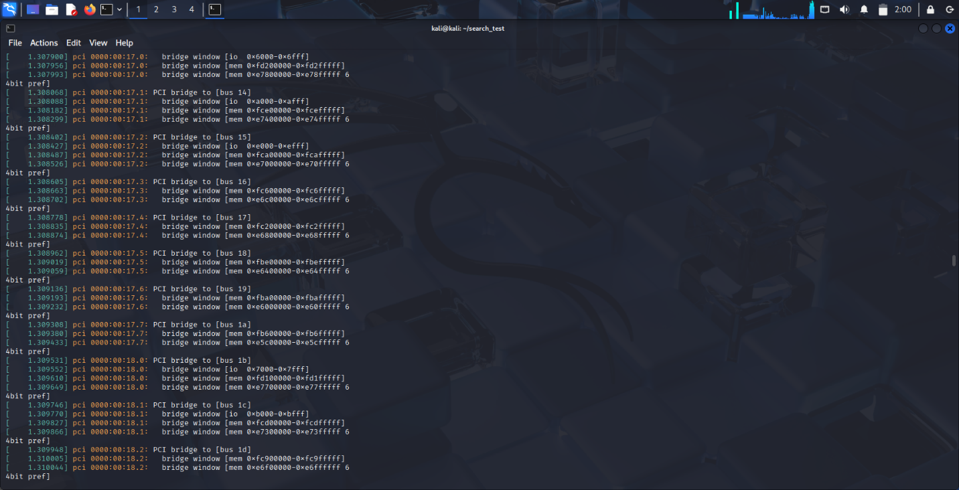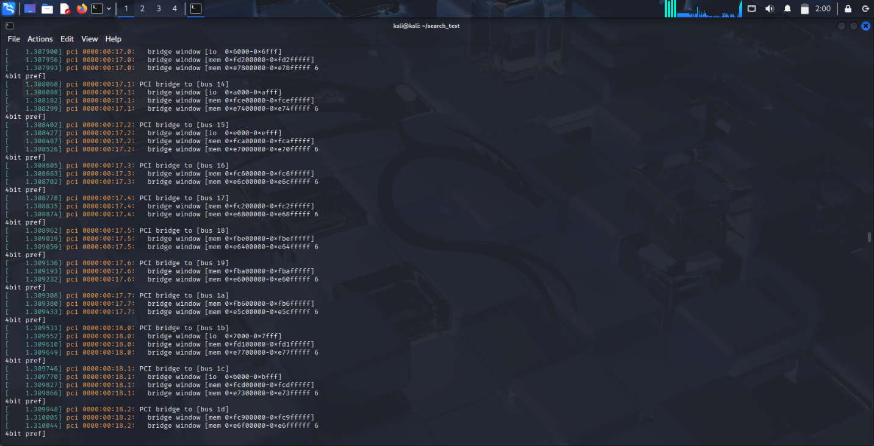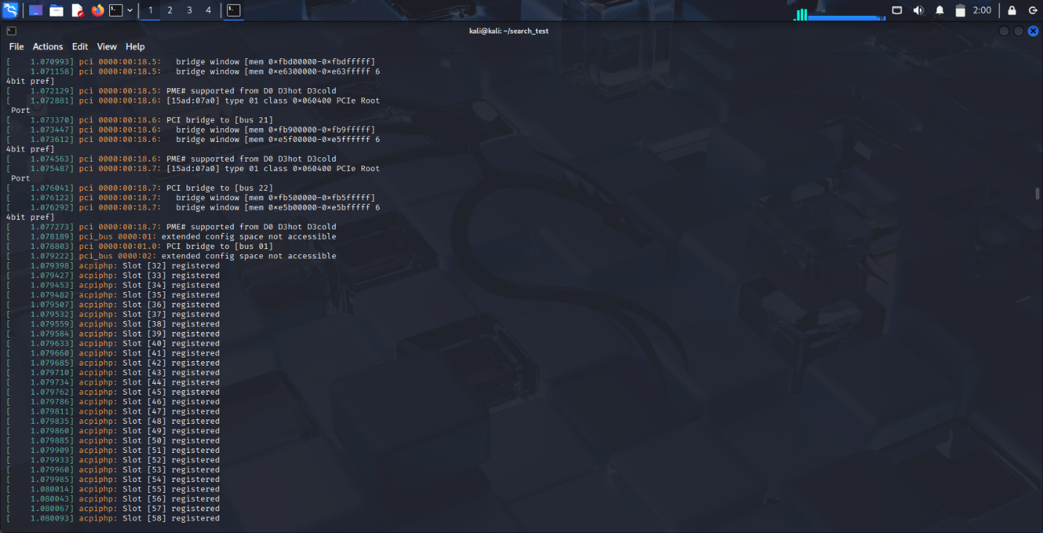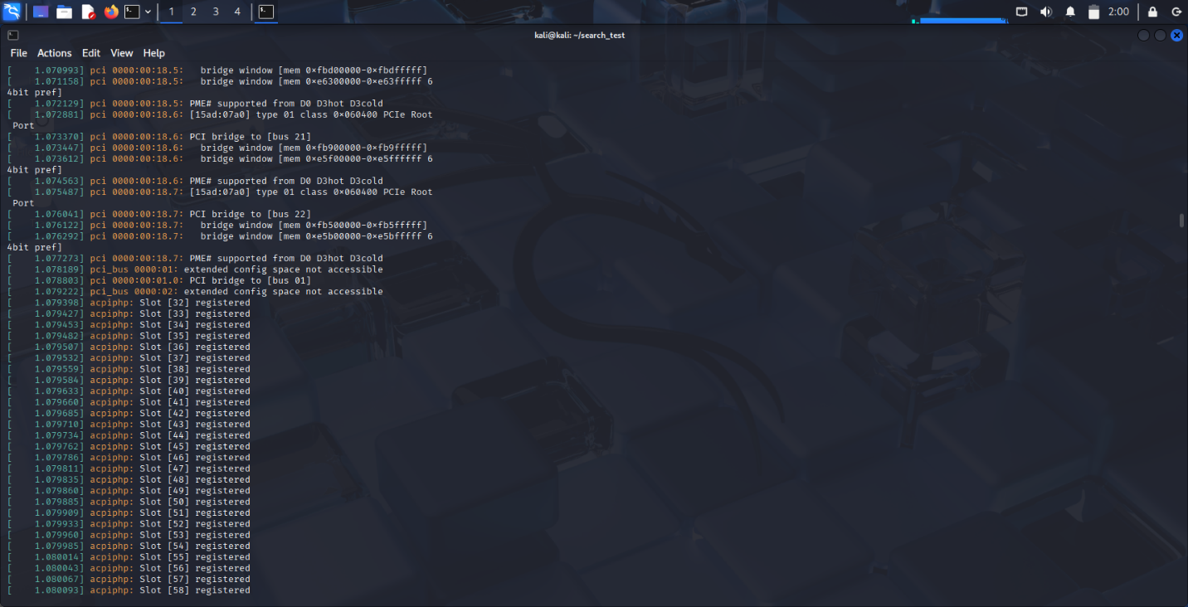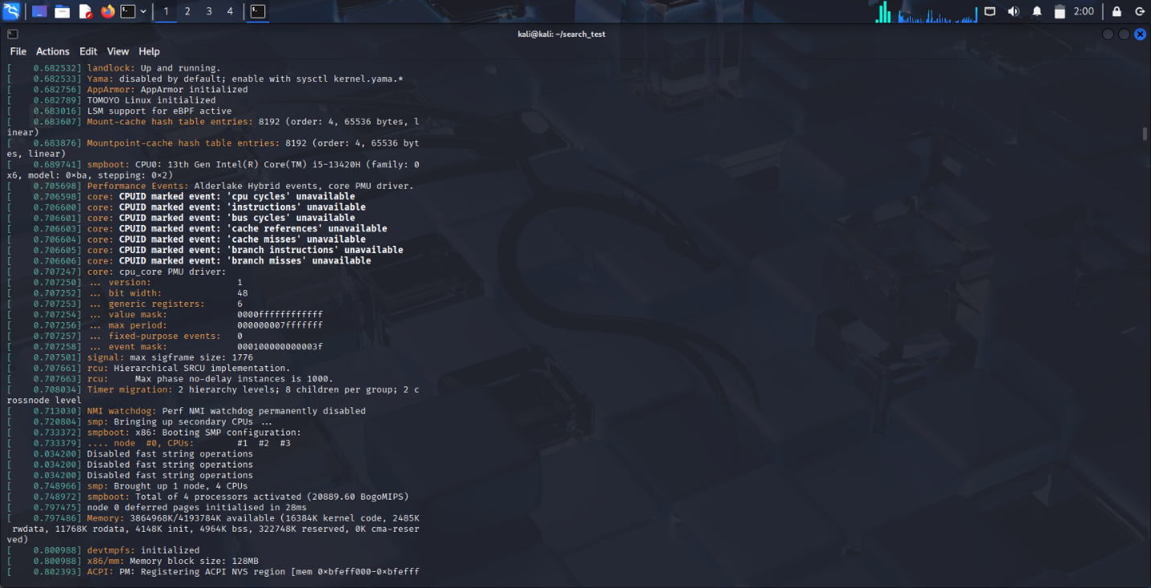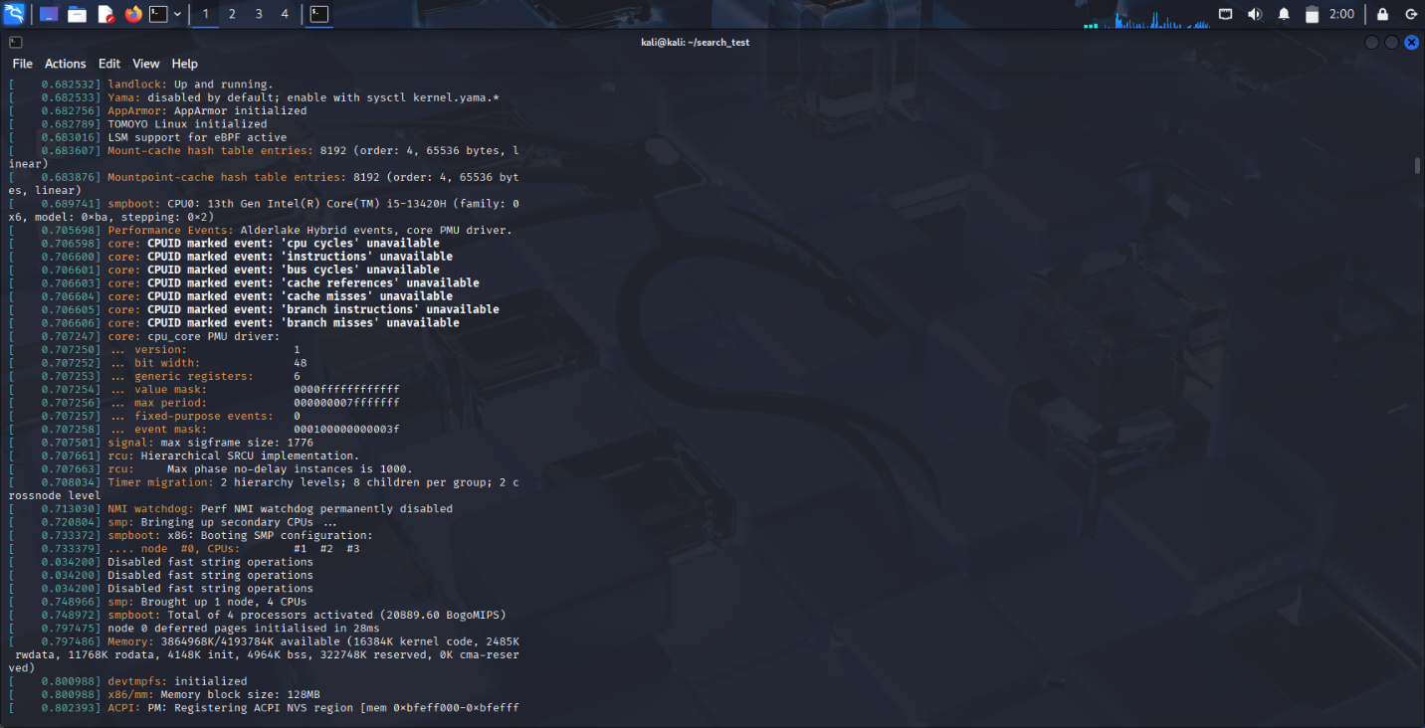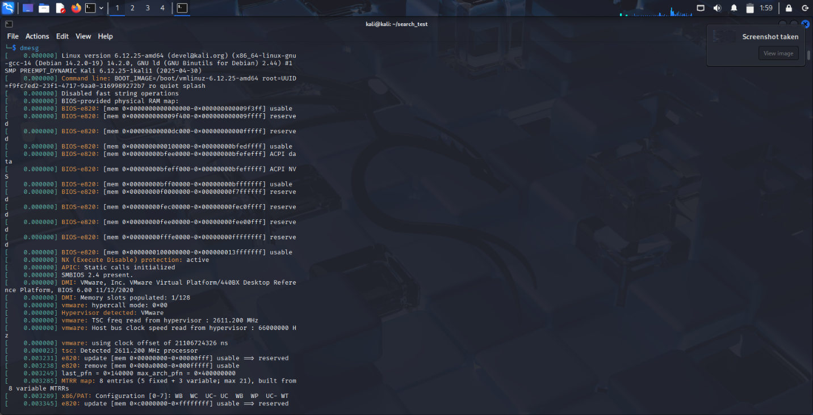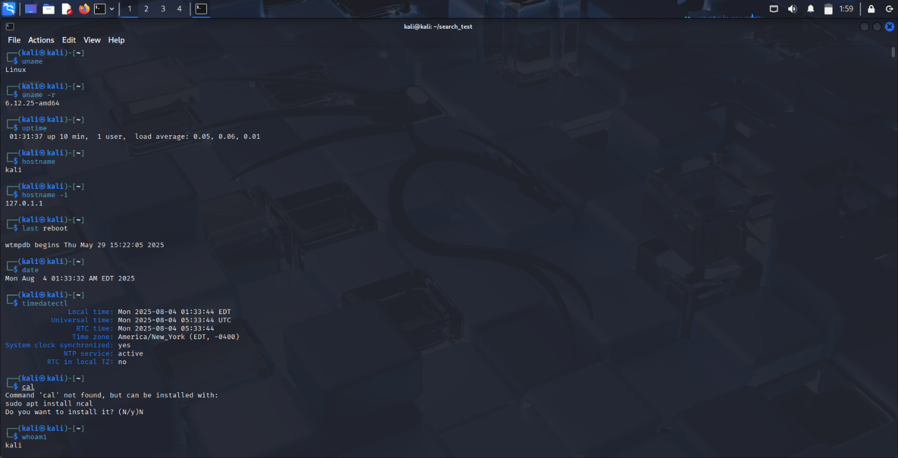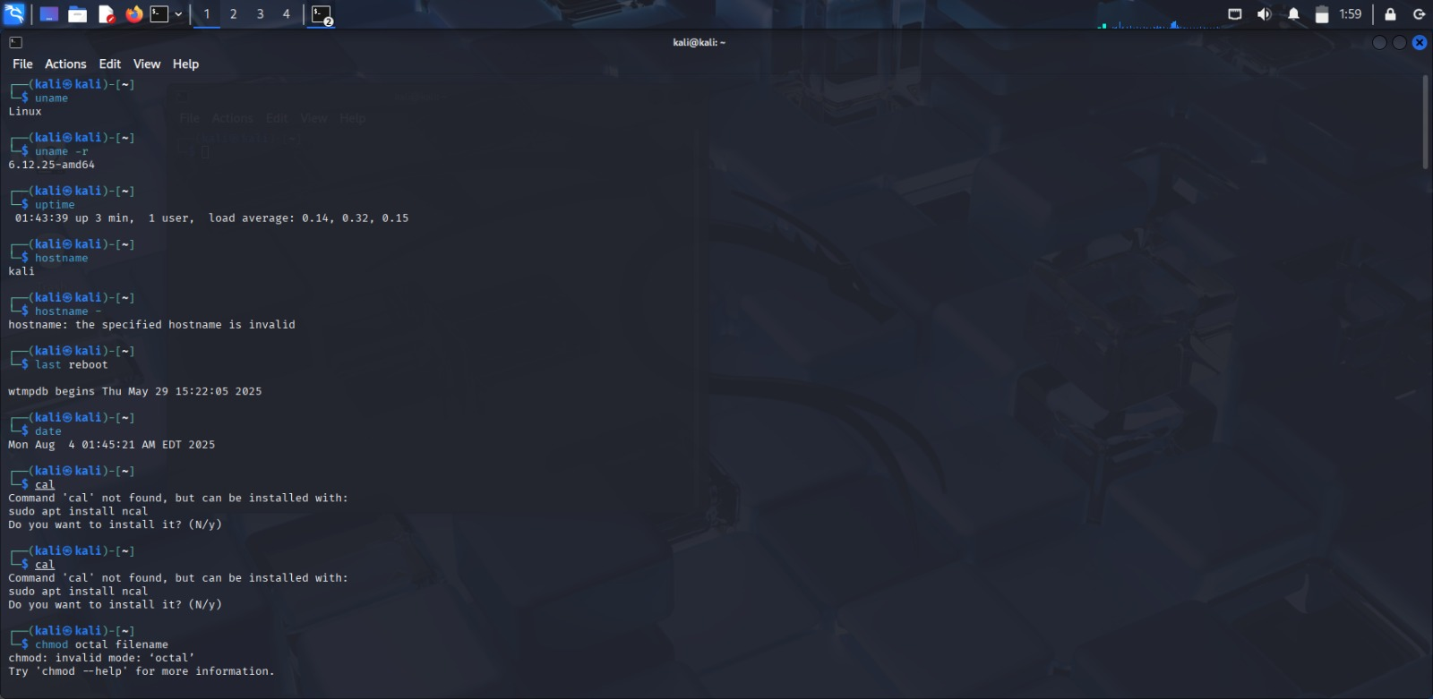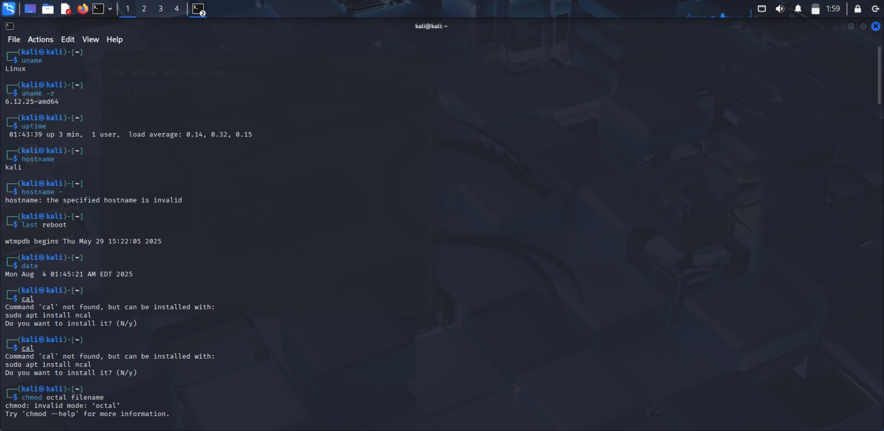

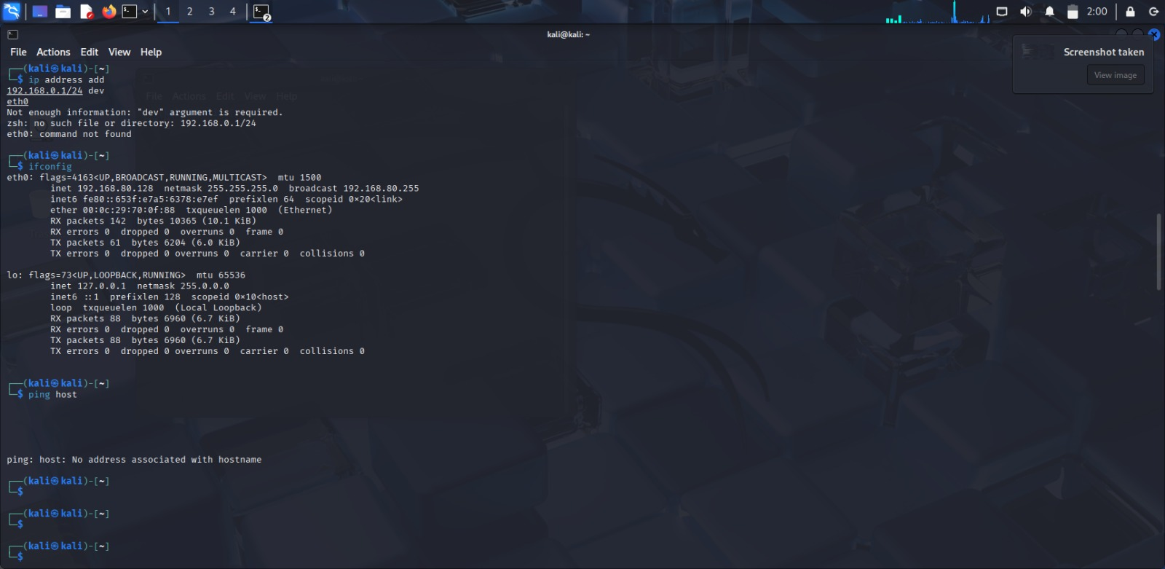

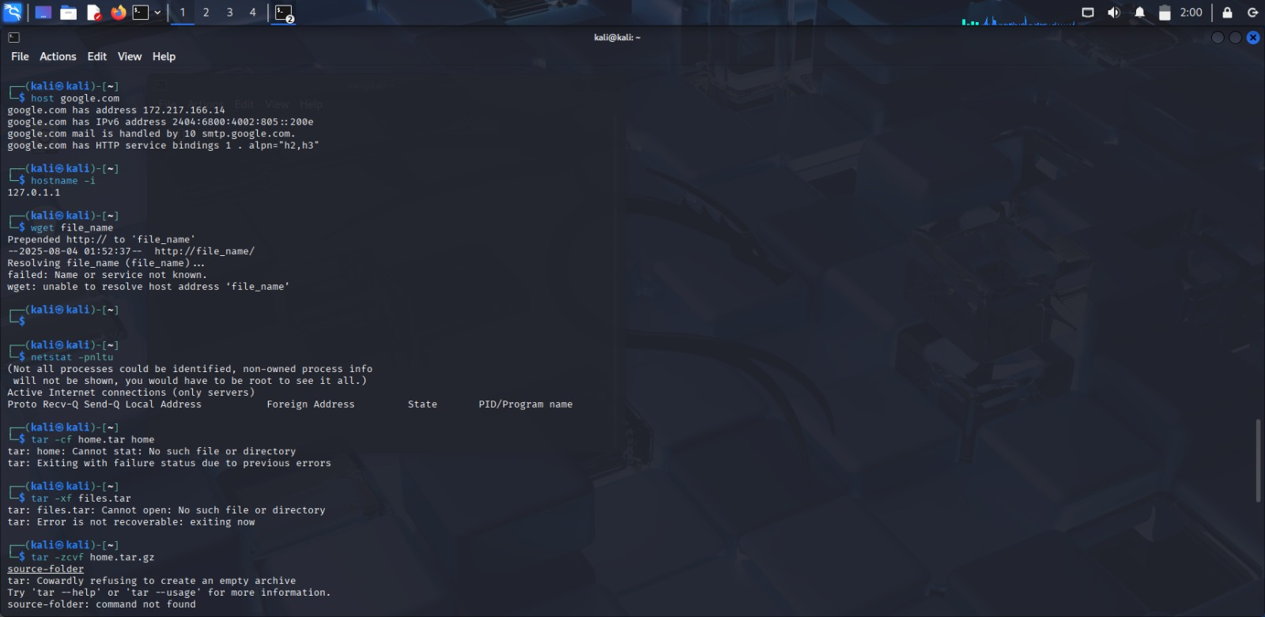

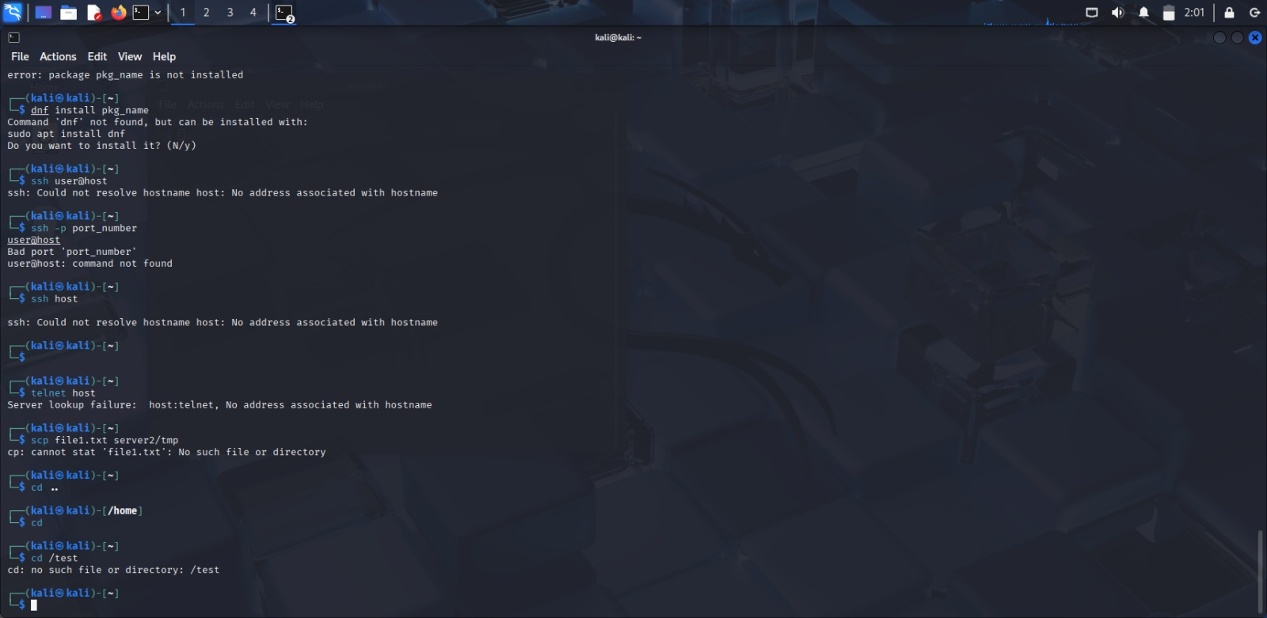

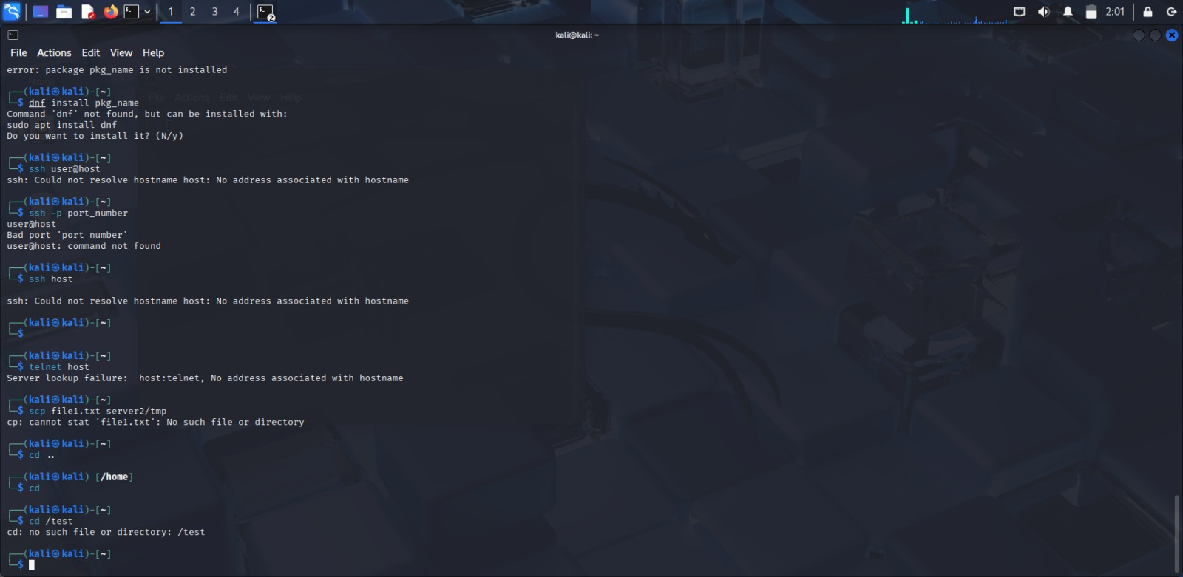

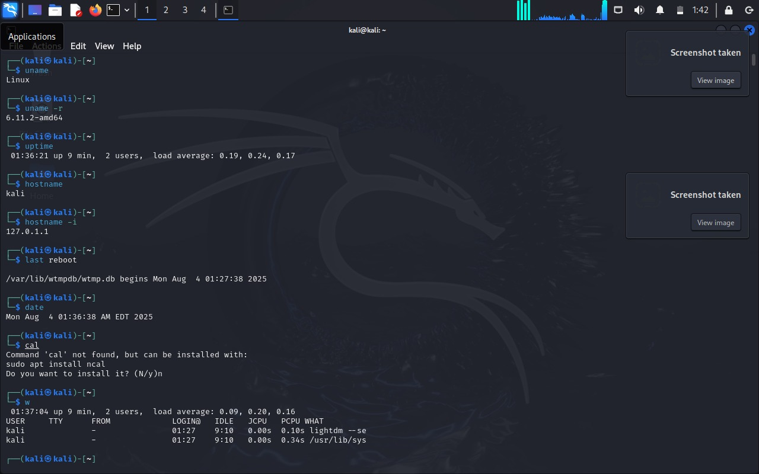

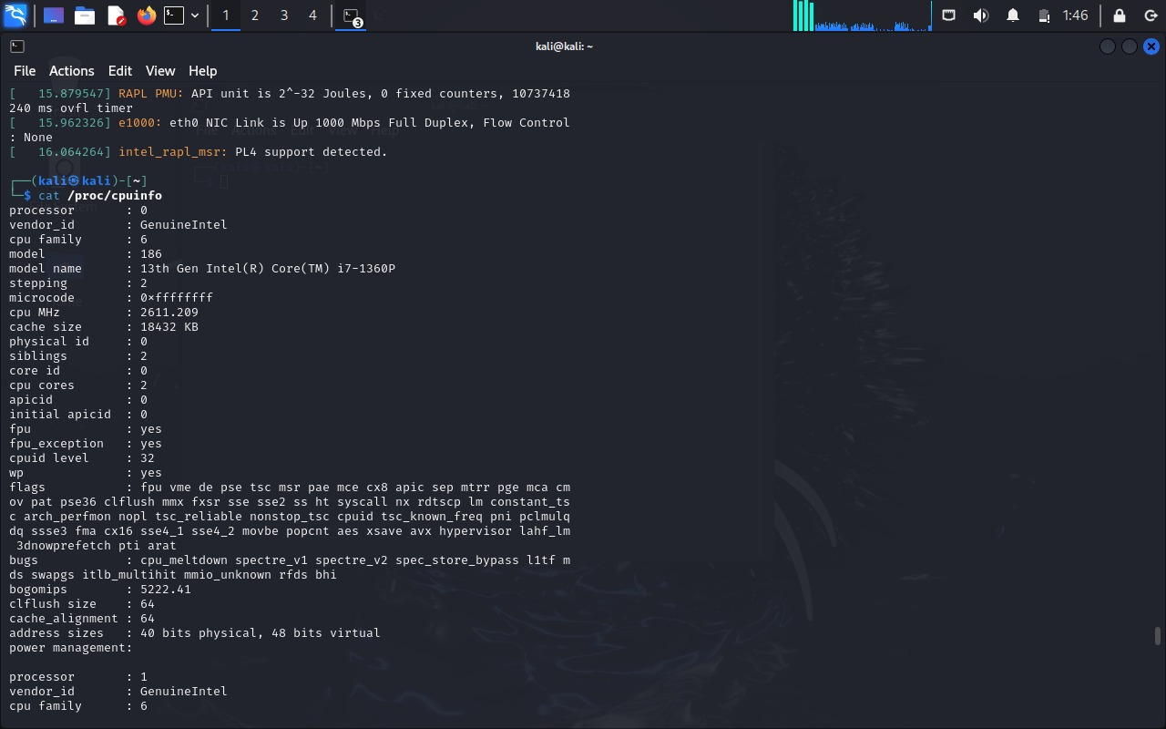 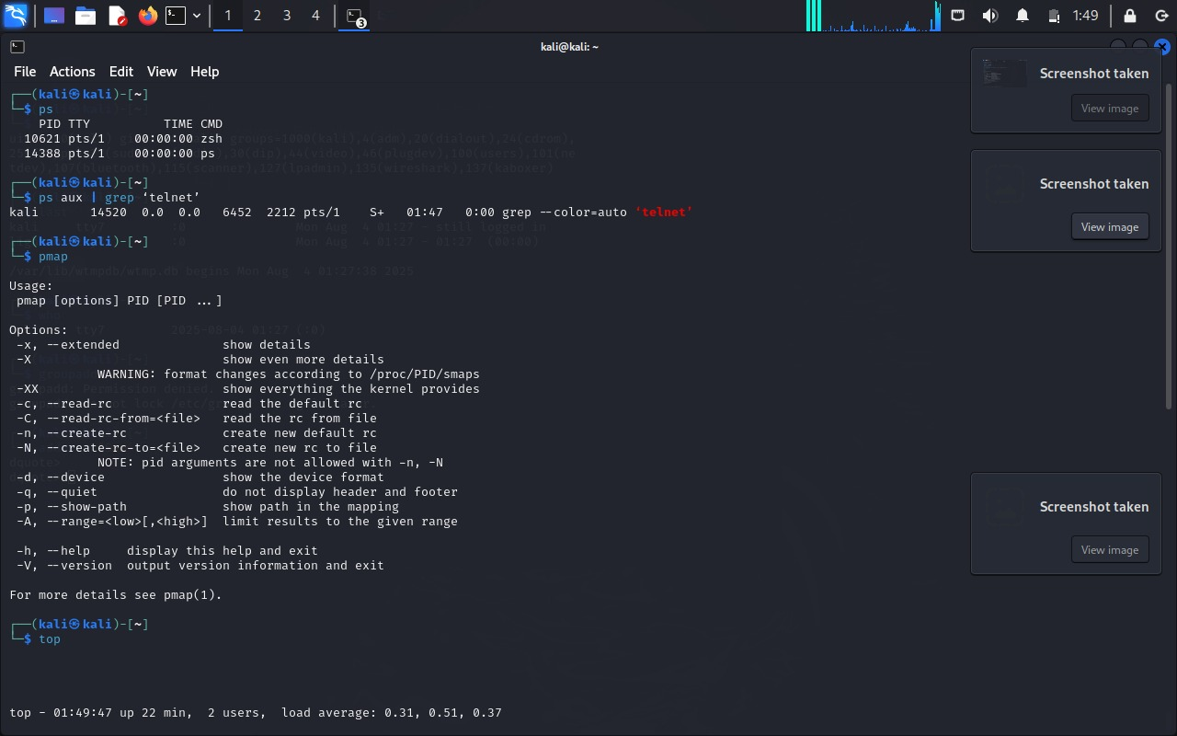





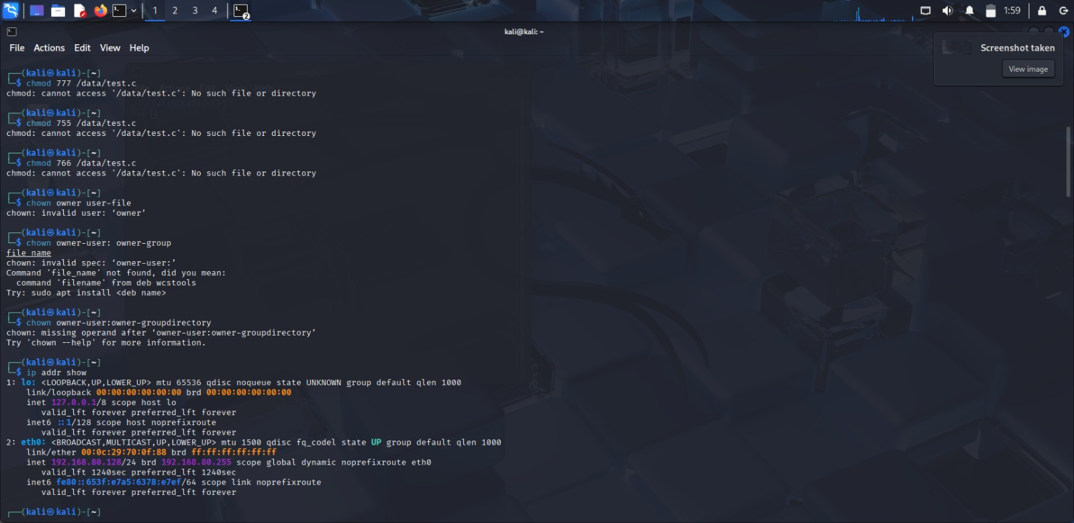 

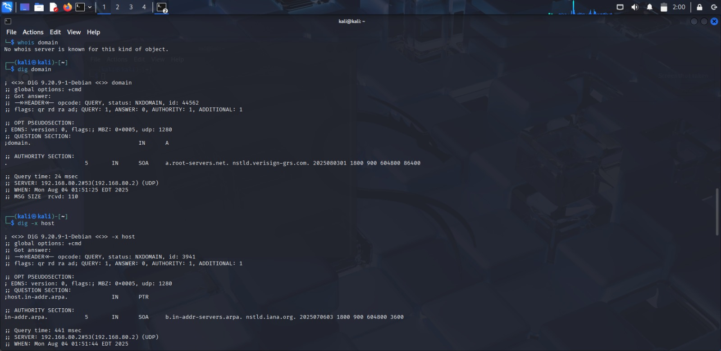 

**Experiment No: 2**

|  |
| --- |
| **Student Name and Roll Number: Nishant Rajora 23csu220** |
| **Semester /Section: 5th DS-A** |
| **Link to Code:** |
| **Date:**  **18-08-2025** |
| **Faculty Signature: Dr. Asha Sohal** |
| **Marks:** |

|  |
| --- |
| **Objective(s):**  To write the shell programming code for the following. |
| **Outcome:**   * Student is able to write code in shell programming. |
| **Problem Statement:**  a) Write A Shell Program of Hello World  b) Write a shell program to find factorial of a number.  c) Write a shell program to find gross salary of an employee.  d) Write a shell program to display the menu and execute instructions accordingly   * (i)List of files (ii)Process Status (iii) Date (iv) users in program (v) Quit |
| **Background Study:**  A shell script is a file with a set of commands in it. The shell reads this file and executes the instructions as if they were input directly on the command line.  A shell is a command-line interpreter and operations such as file manipulation, program execution and text printing are performed by shell script. So, we will use vi editor to edit our files. |
| **Question Bank:**  1. What is a shell? **Answer: A shell is a command-line interpreter that provides the interface between the user and the operating system kernel.**  2. What is the significance of $#? **Answer: In shell scripting, $# represents the number of command-line arguments passed to the script.**  3. What are the different types of commonly used shells on a typical Linux system? **Answer: sh, bash, csh, ksh, zsh, fish.**  4. How will you pass and access arguments to a script in Linux? **Answer: Arguments are passed after the script name and accessed using $0 for script name, $1 for first argument, $2 for second argument, $@ for all arguments, $# for number of arguments.**  5. Use sed command to replace the content of the file (emulate tac command) **Answer: sed '1!G;h;$!d' filename** |

**Student Work Area**

**Algorithm/Flowchart/Code/Sample Output**

1. Write A Shell Program of Hello World

#!/bin/bash

echo "Hello World"

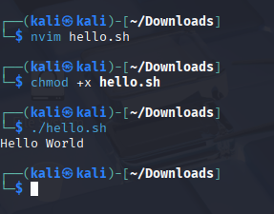

b) Write a shell program to find factorial of a number.

#!/bin/bash

echo -n "Enter a number: "

read num

fact=1

for ((i=1; i<=num; i++))

do

fact=$((fact * i))

done

echo "Factorial of $num is $fact"

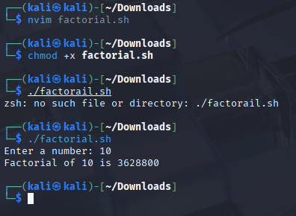

c) Write a shell program to find gross salary of an employee.

#!/bin/bash

echo -n "Enter Basic Salary: "

read basic

da=$(( (basic * 40) / 100 )) # 40% DA

hra=$(( (basic * 20) / 100 )) # 20% HRA

gross=$((basic + da + hra))

echo "Basic Salary : Rs.$basic"

echo "DA (40%) : Rs.$da"

echo "HRA (20%) : Rs.$hra"

echo "Gross Salary : Rs.$gross"

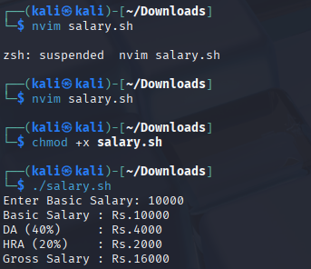

d) Write a shell program to display the menu and execute instructions accordingly

(i)List of files (ii)Process Status (iii) Date (iv) users in program (v) Quit

#!/bin/bash

while true

do

echo " MENU "

echo "1. List of files"

echo "2. Process Status"

echo "3. Date"

echo "4. Users in system"

echo "5. Quit"

echo -n "Enter your choice: "

read ch

case $ch in

1) ls ;;

2) ps ;;

3) date ;;

4) who ;;

5) echo "Exiting..."; exit ;;

*) echo "Invalid choice" ;;

esac

done

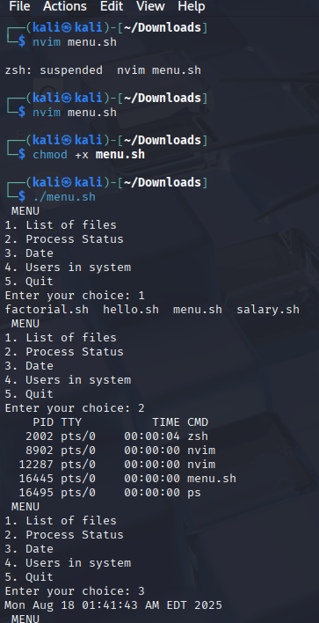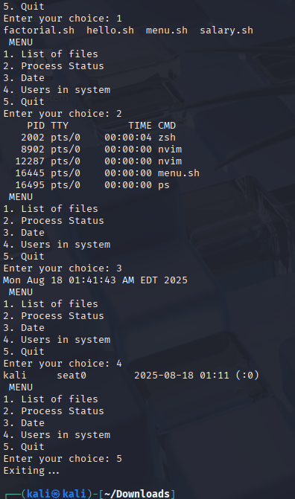

**EXPERIMENT NO. 3**

|  |
| --- |
| **Student Name and Roll Number:** |
| **Semester /Section: 5th DS-A** |
| **Link to Code:** |
| **Date: 25/08/2035** |
| **Faculty Signature: Dr. Asha Sohal** |
| **Marks:** |

|  |
| --- |
| **Objective:**  To write the shell programming code for the following. |
| **Outcome:**  Student is able to write code in shell programming |
| **Problem Statement:**  a) Write a shell program to find Fibonacci series.  b) Write a shell program to find largest of three numbers.  c) Write a shell program to find average of N numbers |
| **Background Study:**  A shell script is a file with a set of commands in it. The shell reads this file and executes the instructions as if they were input directly on the command line.  A shell is a command-line interpreter and operations such as file manipulation, program execution and text printing are performed by shell script. So, we will use vi editor to edit our files. |
| **Question Bank:**  1. How to use multi line comments in shell script? **Answer: Use : ' comment block ' or <<COMMENT ... COMMENT.**  2. What is the difference between soft and hard links? **Answer: Soft link is a shortcut to the original file and gets broken if the original file is deleted. Hard link is another name for the same file and remains valid even if the original file is deleted.**  3. Explain about loops and what are the loops available in LINUX? **Answer: Loops are used to repeat commands. The available loops are for loop, while loop, and until loop.**  4. What are absolute and relative paths**. Answer: Absolute path specifies the location from the root directory (e.g., /home/user/file). Relative path specifies the location relative to the current working directory (e.g., ./file or ../file).**  5. How to debug a shell script. **Answer: Run the script with bash -x script.sh or add set -x at the beginning of the script.** |

**Student Work Area**

**Algorithm/Flowchart/Code/Sample Outputs**

1. Write a shell program to find Fibonacci series.

#!/bin/bash

echo -n "Enter number of terms: "

read n

a=0

b=1

echo "Fibonacci Series up to $n terms:"

for (( i=0; i<n; i++ ))

do

echo -n "$a "

fn=$((a + b))

a=$b

b=$fn

done

echo

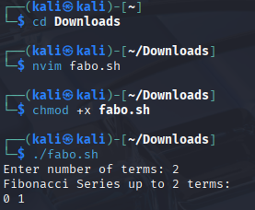

1. Write a shell program to find largest of three numbers.

#!/bin/bash

echo "Enter three numbers: "

read a b c

if [ $a -ge $b ] && [ $a -ge $c ]

then

echo "$a is the largest"

elif [ $b -ge $a ] && [ $b -ge $c ]

then

echo "$b is the largest"

else

echo "$c is the largest"

fi

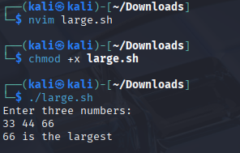

c) Write a shell program to find average of N numbers

#!/bin/bash

echo -n "Enter how many numbers: "

read n

sum=0

echo "Enter $n numbers:"

for (( i=1; i<=n; i++ ))

do

read num

sum=$((sum + num))

done

avg=$((sum / n))

echo "Average = $avg"

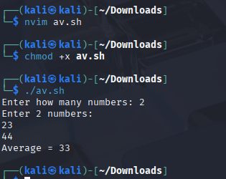

**EXPERIMENT NO. 4**

|  |
| --- |
| **Student Name and Roll Number:** |
| **Semester /Section: 5th DS-A** |
| **Link to Code:** |
| **Date: 08/09/2025** |
| **Faculty Signature: Dr. Asha Sohal** |
| **Marks:** |

|  |
| --- |
| **Objective:**  To write the shell programming code for the following. |
| **Outcome:**  Student is able to write code in shell programming |
| **Problem Statement:**  a) Write a shell program to check whether a number is even or odd  b) Write a shell program to find whether a number is prime or not.  c) Write a shell program to find whether a number is palindrome or not.  d) Write a shell program to type number 1 to 7 and then print its corresponding day of week |
| **Background Study:**  A shell script is a file with a set of commands in it. The shell reads this file and executes the instructions as if they were input directly on the command line.  A shell is a command-line interpreter and operations such as file manipulation, program execution and text printing is performed by shell script. So, we will use vi editor to edit our files. |
| **Question Bank:**  1. What are Zombie Process? **Answer: A zombie process is a process that has completed execution but still has an entry in the process table waiting for the parent to read its exit status.**  2. What are different types of variables used in shell script? **Answer: System variables (e.g., $HOME, $USER, $PATH) and User-defined variables created by the programmer.**  3. What are the different types of modes available in Vi editor? **Answer: Command mode, Insert mode, and Last line (Ex) mode.**  4. What are the different types of permission at file level in shell? **Answer: Read (r), Write (w), and Execute (x) for User, Group, and Others.**  5. How to use comments in shell script. **Answer: Use # at the beginning of the line for single-line comments.** |

**Student Work Area**

**Algorithm/Flowchart/Code/Sample output**

1. Write a shell program to check whether a number is even or odd

#!/bin/bash

echo -n "Enter a number: "

read num

if (( num % 2 == 0 ))

then

echo "$num is Even"

else

echo "$num is Odd"

fi

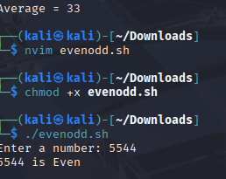

1. Write a shell program to find whether a number is prime or not.

#!/bin/bash

echo -n "Enter a number: "

read num

if [ $num -le 1 ]

then

echo "$num is not a prime number"

exit

fi

is_prime=1 # assume prime

for (( i=2; i<=num/2; i++ ))

do

if (( num % i == 0 ))

then

is_prime=0

break

fi

done

if [ $is_prime -eq 1 ]

then

echo "$num is a Prime number"

else

echo "$num is Not a Prime number"

fi

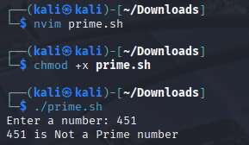

1. Write a shell program to find whether a number is palindrome or not.

#!/bin/bash

echo -n "Enter a number: "

read num

rev=0

temp=$num

while [ $temp -gt 0 ]

do

digit=$((temp % 10))

rev=$((rev * 10 + digit))

temp=$((temp / 10))

done

if [ $num -eq $rev ]

then

echo "$num is a Palindrome"

else

echo "$num is Not a Palindrome"

fi

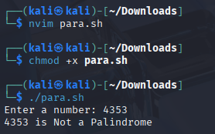

1. Write a shell program to type number 1 to 7 and then print its corresponding day of week

#!/bin/bash

echo -n "Enter a number (1-7): "

read n

case $n in

1) echo "Monday" ;;

2) echo "Tuesday" ;;

3) echo "Wednesday" ;;

4) echo "Thursday" ;;

5) echo "Friday" ;;

6) echo "Saturday" ;;

7) echo "Sunday" ;;

*) echo "Invalid number! Please enter 1–7" ;;

Esac

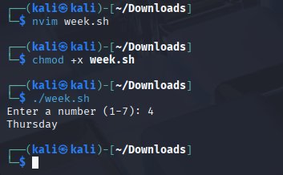

**Experiment No: 5**

|  |
| --- |
| **Student Name and Roll Number: Nishant Rajora 23csu220** |
| **Semester /Section: 5th DS-A** |
| **Link to Code:** |
| **Date: 08/09/2025** |
| **Faculty Signature: Dr. Asha Sohal** |
| **Marks:** |

|  |
| --- |
| **Objective:**  Write a program to implement CPU scheduling for first come first serve approach. |
| **Outcome:**  The students will understand the First-cum-first-serve algorithm |
| **Problem Statement:**  Implement the following CPU scheduling Algorithms.   1. FCFS with Arrival time 2. FCFS without Arrival time |
| **Background Study:**  **FCFS**   * The simplest CPU-scheduling algorithm is the first-come, first-served (FCFS) scheduling algorithm. With this algorithm, processes are assigned the CPU in the order they request it. * There is a single queue of ready processes. * The implementation of the FCFS policy is easily managed with a FIFO queue. When a process enters the ready queue, its PCB is linked onto the tail of the queue. * The average waiting time under the FCFS policy, however, is often quite long. |
| **Question Bank:**   1. Which module gives control of the CPU to the process selected by the short-term scheduler?    1. **dispatche**r    2. interrupt    3. scheduler    4. none of the mentioned 2. The processes that are residing in main memory and are ready and waiting to execute are kept on a list called    1. job queue    2. **ready queue**    3. execution queue    4. process queue 3. The interval from the time of submission of a process to the time of completion is termed as    1. waiting time    2. **turnaround time**    3. response time    4. throughput 4. Which scheduling algorithm allocates the CPU first to the process that requests the CPU first?    1. **first-come, first-served scheduling**    2. shortest job scheduling    3. priority scheduling    4. none of the mentioned 5. In priority scheduling algorithm    1. **CPU is allocated to the process with highest priority**    2. CPU is allocated to the process with lowest priority    3. equal priority processes cannot be scheduled    4. none of the mentioned |

**Student Work Area**

**Algorithm/Flowchart/Code/Sample Outputs**

#!/bin/bash

echo "Enter number of processes:"; read n

bt=(); wt=(); tat=()

echo "Enter burst times:"

for ((i=0;i<n;i++)); do read bt[$i]; done

wt[0]=0

for ((i=1;i<n;i++)); do wt[$i]=$((wt[i-1]+bt[i-1])); done

for ((i=0;i<n;i++)); do tat[$i]=$((wt[i]+bt[i])); done

echo "P BT WT TAT"

tw=0; tt=0

for ((i=0;i<n;i++)); do

echo "P$((i+1)) ${bt[i]} ${wt[i]} ${tat[i]}"

tw=$((tw+wt[i])); tt=$((tt+tat[i]))

done

echo "Avg WT=$((tw/n))"

echo "Avg TAT=$((tt/n))"

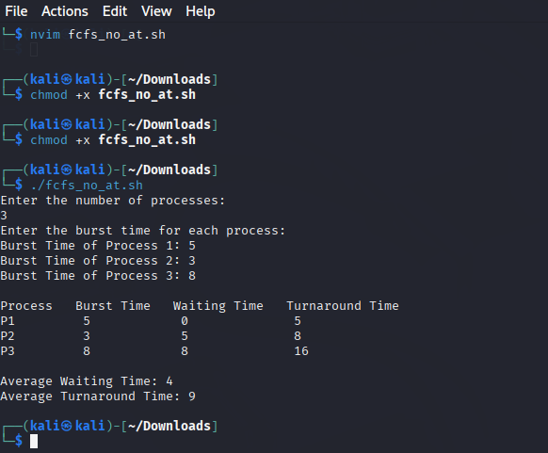

#!/bin/bash

echo "Enter number of processes:"; read n

pid=(); at=(); bt=(); ct=(); wt=(); tat=()

for ((i=0;i<n;i++)); do pid[$i]=$((i+1)); read -p "AT of P$((i+1)): " at[$i]; read -p "BT of P$((i+1)): " bt[$i]; done

for ((i=0;i<n-1;i++)); do for ((j=0;j<n-i-1;j++)); do if [ ${at[j]} -gt ${at[j+1]} ]; then t=${at[j]}; at[j]=${at[j+1]}; at[j+1]=$t; t=${bt[j]}; bt[j]=${bt[j+1]}; bt[j+1]=$t; t=${pid[j]}; pid[j]=${pid[j+1]}; pid[j+1]=$t; fi; done; done

ct[0]=$((at[0]+bt[0]))

for ((i=1;i<n;i++)); do if [ ${ct[i-1]} -lt ${at[i]} ]; then ct[$i]=$((at[i]+bt[i])); else ct[$i]=$((ct[i-1]+bt[i])); fi; done

for ((i=0;i<n;i++)); do tat[$i]=$((ct[i]-at[i])); wt[$i]=$((tat[i]-bt[i])); done

echo "PID AT BT CT WT TAT"

tw=0; tt=0

for ((i=0;i<n;i++)); do echo "P${pid[i]} ${at[i]} ${bt[i]} ${ct[i]} ${wt[i]} ${tat[i]}"; tw=$((tw+wt[i])); tt=$((tt+tat[i])); done

echo "Avg WT=$((tw/n))"

echo "Avg TAT=$((tt/n))"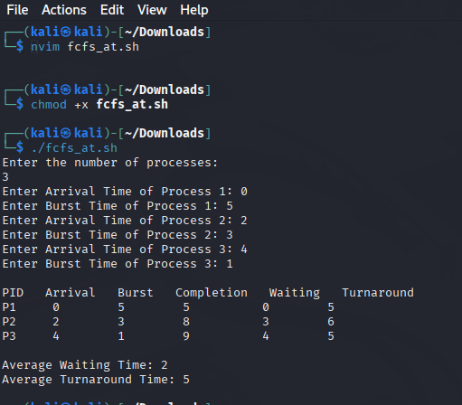

**Experiment No: 6**

|  |
| --- |
| **Student Name and Roll Number: Nishant Rajora 23csu220** |
| **Semester /Section: 5th DS-A** |
| **Link to Code:** |
| **Date: 09/09/2025** |
| **Faculty Signature: Dr. Asha Sohal** |
| **Marks:** |

|  |
| --- |
| **Objective:**  Write a program to implement CPU scheduling for shortest job first (Preemptive and Non-Preemptive) |
| **Outcome:**  The students will understand the Shortest Job First scheduling mechanism |
| **Problem Statement:**  Implement the following CPU scheduling Algorithms.   * SJF (Non-Preemptive) * SJTF (shortest remaining time first -Preemptive SJF) |
| **Background Study:**   * Shortest Job first is having the advantage of a minimum average waiting time . * This algorithm associates with each process the length of the process next burst time.When CPU is available it assigned to the process that has the smallest next CPU burst time.if CPU burst time of two process is same then it follows FCFS. * It may cause starvation if shorter processes keep coming. This problem can be solved using the concept of ageing. * It is practically infeasible as Operating System may not know burst time and therefore may not sort them. |
| **Question Bank:**   1. [scheduling algorithm](https://t4tutorials.com/round-robin-process-scheduling-algorithm-in-operating-systems/) In multilevel feedback A. processes are not classified into groups **B. a process can move to a different classified ready queue…** C. classification of the ready queue is permanent D. none of the mentioned 2. Select one which algorithms tend to minimize the process flow time? A. First come First served B. Earliest Deadline First **C. Shortest Job First** D. Longest Job First 3. The process can be classified into many groups in A. [shortest job scheduling algorithm](https://t4tutorials.com/shortest-job-first-scheduling-sjf-process-scheduling-in-operating-systems/) B. multilevel queue scheduling algorithm C. round-robin scheduling algorithm D. priority scheduling algorithm 4. The turnaround time for short jobs during multiprogramming is usually Shortened and that for long jobs is slightly ___________ A. Shortened B. Unchanged **C. Lengthened** D. Shortened 5. Time quantum can be said A. multilevel queue scheduling algorithm **B. round-robin scheduling algorithm** C. shortest job scheduling algorithm D. priority scheduling algorithm |

**Student Work Area**

**Algorithm/Flowchart/Code/Sample Outputs**

#!/bin/bash

echo "Enter number of processes:"; read n

pid=(); at=(); bt=(); ct=(); wt=(); tat=(); donep=()

for ((i=0;i<n;i++)); do pid[$i]=$((i+1)); read -p "AT of P$((i+1)): " at[$i]; read -p "BT of P$((i+1)): " bt[$i]; done

time=0; comp=0

while [ $comp -lt $n ]; do min=9999; idx=-1

for ((i=0;i<n;i++)); do if [ ${at[i]} -le $time ] && [[ ! " ${donep[@]} " =~ " $i " ]]; then if [ ${bt[i]} -lt $min ]; then min=${bt[i]}; idx=$i; fi; fi; done

if [ $idx -eq -1 ]; then time=$((time+1)); else time=$((time+bt[idx])); ct[$idx]=$time; tat[$idx]=$((ct[idx]-at[idx])); wt[$idx]=$((tat[idx]-bt[idx])); donep+=($idx); comp=$((comp+1)); fi

done

echo "PID AT BT CT WT TAT"

tw=0; tt=0

for ((i=0;i<n;i++)); do echo "P${pid[i]} ${at[i]} ${bt[i]} ${ct[i]} ${wt[i]} ${tat[i]}"; tw=$((tw+wt[i])); tt=$((tt+tat[i])); done

echo "Avg WT=$((tw/n))"

echo "Avg TAT=$((tt/n))"

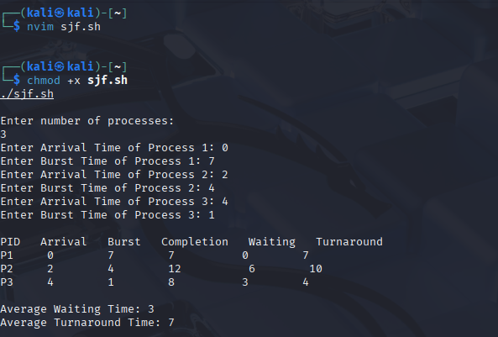

#!/bin/bash

echo "Enter number of processes:"; read n

pid=(); at=(); bt=(); rem=(); ct=(); wt=(); tat=()

for ((i=0;i<n;i++)); do pid[$i]=$((i+1)); read -p "AT of P$((i+1)): " at[$i]; read -p "BT of P$((i+1)): " bt[$i]; rem[$i]=${bt[$i]}; done

time=0; comp=0

while [ $comp -lt $n ]; do min=9999; idx=-1

for ((i=0;i<n;i++)); do if [ ${at[i]} -le $time ] && [ ${rem[i]} -gt 0 ]; then if [ ${rem[i]} -lt $min ]; then min=${rem[i]}; idx=$i; fi; fi; done

if [ $idx -eq -1 ]; then time=$((time+1)); else rem[$idx]=$((rem[idx]-1)); time=$((time+1)); if [ ${rem[idx]} -eq 0 ]; then ct[$idx]=$time; tat[$idx]=$((ct[idx]-at[idx])); wt[$idx]=$((tat[idx]-bt[idx])); comp=$((comp+1)); fi; fi

done

echo "PID AT BT CT WT TAT"

tw=0; tt=0

for ((i=0;i<n;i++)); do echo "P${pid[i]} ${at[i]} ${bt[i]} ${ct[i]} ${wt[i]} ${tat[i]}"; tw=$((tw+wt[i])); tt=$((tt+tat[i])); done

echo "Avg WT=$((tw/n))"

echo "Avg TAT=$((tt/n))"

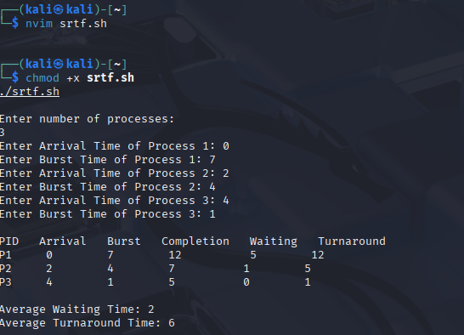

**Experiment No: 7**

|  |
| --- |
| **Student Name and Roll Number: Nishant Rajora 23csu220** |
| **Semester /Section: 5th DS-A** |
| **Link to Code:** |
| **Date: 08/09/2025** |
| **Faculty Signature: Dr. Asha Sohal** |
| **Marks:** |

|  |
| --- |
| **Objective:**  Write a program to perform priority scheduling among a set of processes. |
| **Outcome:**  Student will understand the working of priority scheduling among a set of processes. |
| **Problem Statement:**  Implement the priority scheduling. |
| **Background Study:**  Priority scheduling is a non-preemptive algorithm and used in batch systems. Each process is assigned a priority. Process with highest priority is to be executed first and so on. |
| **Question Bank:**   1. What are advantages of Priority scheduling?   **Sol.** **Easy to use scheduling method. Processes are executed on the basis of priority so high priority does not need to wait for long which saves time.**   1. What are disadvantages of priority scheduling?   **Sol.** **The major disadvantage of priority scheduling is the process of indefinite blocking or starvation. This problem appears when a process is ready to be executed but it has to wait for the long time for execution by CPU because other high priority processes are executed by the CPU.**   1. At the ready queue when a process arrives In [priority scheduling](https://t4tutorials.com/priority-based-process-scheduling-in-operating-systems/) algorithm, the priority of this process is compared with the priority of? A. currently running process B. parent process **C. all process** D. init process 2. Differentiate between pre-emptive and non pre-emptive scheduling?   **Sol. The basic difference between preemptive and non-preemptive scheduling is that in preemptive scheduling the CPU is allocated to the processes for the limited time. While in Non-preemptive scheduling, the CPU is allocated to the process till it terminates or switches to waiting state.** |

**Student Work Area**

**Algorithm/Flowchart/Code/Sample Outputs**

#!/bin/bash

echo "Enter number of processes:"; read n

pid=(); bt=(); prio=(); ct=(); wt=(); tat=()

for ((i=0;i<n;i++)); do pid[$i]=$((i+1)); read -p "BT of P$((i+1)): " bt[$i]; read -p "Priority of P$((i+1)): " prio[$i]; done

for ((i=0;i<n-1;i++)); do for ((j=0;j<n-i-1;j++)); do if [ ${prio[j]} -gt ${prio[j+1]} ]; then t=${prio[j]}; prio[j]=${prio[j+1]}; prio[j+1]=$t; t=${bt[j]}; bt[j]=${bt[j+1]}; bt[j+1]=$t; t=${pid[j]}; pid[j]=${pid[j+1]}; pid[j+1]=$t; fi; done; done

ct[0]=${bt[0]}

for ((i=1;i<n;i++)); do ct[$i]=$((ct[i-1]+bt[i])); done

for ((i=0;i<n;i++)); do tat[$i]=${ct[i]}; wt[$i]=$((tat[i]-bt[i])); done

echo "PID BT Priority CT WT TAT"

tw=0; tt=0

for ((i=0;i<n;i++)); do echo "P${pid[i]} ${bt[i]} ${prio[i]} ${ct[i]} ${wt[i]} ${tat[i]}"; tw=$((tw+wt[i])); tt=$((tt+tat[i])); done

echo "Avg WT=$((tw/n))"

echo "Avg TAT=$((tt/n))"

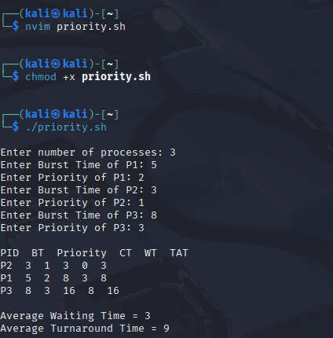

**Experiment No: 8**

|  |
| --- |
| **Student Name and Roll Number: Nishant Rajora 23csu220** |
| **Semester /Section: 5th DS-A** |
| **Link to Code:** |
| **Date: 15/09/2025** |
| **Faculty Signature: Dr. Asha Sohal** |
| **Marks:** |

|  |
| --- |
| **Objective: Objective**  To familiarize the students about CPU scheduling Algorithms |
| **Program Outcome**  The students will understand the Round Robin Algorithm. |
| **Problem Statement:**  Implement the Round Robin Algorithm. |
| **Background Study:**   * In Round Robin each process is assigned a fixed time slot in a cyclic way and this is preemptive. It has a disadvantage of context switch and have quantum time |
| **Question Bank:**   1. What is Preemptive and Non- Preemptive CPU scheduling? Explain with examples.   Sol.Preemptive:  In this resources(CPU Cycle) are allocated to a process for a limited time.  Eg. Examples of preemptive scheduling are Round Robin and Shortest Remaining Time First.  Non-Preemptive  Once resources(CPU Cycle) are allocated to a process, the process holds it till it completes its burst time or switches to waiting state.  Eg. Examples of non-preemptive scheduling are First Come First Serve and Shortest Job First.   1. Explain the difference between short term, long term and medium term scheduling.   Sol.Long term: It selects processes from the pool and load them into memory for execution.  Medium term: Process can be reintroduced into the meat and its execution can be continued.  Short term: It selects from among the processes that are ready to execute.   1. Explain the function of Dispatcher and Context Switch mechanism.   Sol. Dispatcher is also responsible for:Context Switching, Switch to user mode, Jumping to proper location when process again restarted  The only work of scheduler is selection of processes.   1. What are the advantages and disadvantages of Round robin?   Sol. Advantages –  Every process gets an equal share of the CPU.  RR is cyclic in nature, so there is no starvation.  Disadvantages –  Setting the quantum too short, increases the overhead and lowers the CPU efficiency, but setting it too long may cause poor response to short processes.  Average waiting time under the RR policy is often long.   1. Give the application are of Robin Robin.   **Sol.** **A popular use of the queue data structure is the scheduling problem in the operating system. Round-robin is one of the simplest scheduling algorithms for processes in an operating system, which assigns time slices to each process in equal portions and in order, handling all processes without priority.** |

**Student Work Area**

**Algorithm/Flowchart/Code/Sample Outputs**

#!/bin/bash

# Round Robin Scheduling Algorithm

# Function to display the Gantt chart

display_gantt_chart() {

echo -e "\nGantt Chart:"

echo "============"

local chart=""

local time_line="0"

local current_time=0

for entry in "${gantt_chart[@]}"; do

IFS=',' read -ra parts <<< "$entry"

local start=${parts[0]}

local end=${parts[1]}

local pid=${parts[2]}

# Add to chart

chart+="| P$pid "

current_time=$end

time_line+="$(printf '%*s' $((end - start)) "")$end"

done

chart+="|"

echo "$chart"

echo "$time_line"

}

# Function to calculate and display results

display_results() {

echo -e "\nProcess Details:"

echo "================"

echo "PID | Arrival | Burst | Completion | Waiting | Turnaround"

echo "----+---------+-------+------------+---------+-----------"

local total_waiting=0

local total_turnaround=0

for ((i=0; i<n; i++)); do

local pid=${processes[i]}

local arrival=${arrival_times[i]}

local burst=${burst_times[i]}

local completion=${completion_times[i]}

local turnaround=$((completion - arrival))

local waiting=$((turnaround - burst))

total_waiting=$((total_waiting + waiting))

total_turnaround=$((total_turnaround + turnaround))

printf "%-3d | %-7d | %-5d | %-10d | %-7d | %-10d\n" \

"$pid" "$arrival" "$burst" "$completion" "$waiting" "$turnaround"

done

local avg_waiting=$(echo "scale=2; $total_waiting / $n" | bc)

local avg_turnaround=$(echo "scale=2; $total_turnaround / $n" | bc)

echo -e "\nAverage Waiting Time: $avg_waiting"

echo "Average Turnaround Time: $avg_turnaround"

}

# Function to implement round robin scheduling

round_robin() {

local remaining=("${burst_times[@]}")

local current_time=0

local completed=0

local queue=()

# Initialize completion times to 0

for ((i=0; i<n; i++)); do

completion_times[i]=0

done

# Add processes that have arrived at time 0

for ((i=0; i<n; i++)); do

if [ ${arrival_times[i]} -eq 0 ]; then

queue+=($i)

fi

done

echo -e "\nStarting Round Robin Scheduling with Time Quantum: $time_quantum"

echo "================================================================="

while [ $completed -lt $n ]; do

if [ ${#queue[@]} -eq 0 ]; then

# If no processes in queue, advance time

((current_time++))

# Check for new arrivals

for ((i=0; i<n; i++)); do

if [ ${arrival_times[i]} -eq $current_time ] && [ ${remaining[i]} -gt 0 ]; then

queue+=($i)

fi

done

continue

fi

# Get the next process from the queue

local idx=${queue[0]}

queue=("${queue[@]:1}") # Remove the first element

echo "Time $current_time: Executing Process ${processes[idx]} (Remaining: ${remaining[idx]})"

# Execute the process for the time quantum or until completion

if [ ${remaining[idx]} -le $time_quantum ]; then

# Process will complete

gantt_chart+=("$current_time,$((current_time + remaining[idx])),${processes[idx]}")

current_time=$((current_time + remaining[idx]))

remaining[idx]=0

completion_times[idx]=$current_time

((completed++))

echo "Time $current_time: Process ${processes[idx]} completed"

else

# Process will not complete in this quantum

gantt_chart+=("$current_time,$((current_time + time_quantum)),${processes[idx]}")

remaining[idx]=$((remaining[idx] - time_quantum))

current_time=$((current_time + time_quantum))

echo "Time $current_time: Process ${processes[idx]} paused (Remaining: ${remaining[idx]})"

fi

# Check for new arrivals during this execution

for ((i=0; i<n; i++)); do

if [ ${arrival_times[i]} -le $current_time ] && [ ${remaining[i]} -gt 0 ] &&

[ $i -ne $idx ] && [[ ! " ${queue[@]} " =~ " $i " ]] &&

[ ${completion_times[i]} -eq 0 ]; then

queue+=($i)

fi

done

# If the current process is not completed, add it back to the queue

if [ ${remaining[idx]} -gt 0 ]; then

queue+=($idx)

fi

done

}

# Main program

echo "Round Robin Scheduling Algorithm"

echo "================================"

# Get number of processes

read -p "Enter the number of processes: " n

# Initialize arrays

declare -a processes

declare -a arrival_times

declare -a burst_times

declare -a completion_times

declare -a gantt_chart

# Get process details

for ((i=0; i<n; i++)); do

echo -e "\nEnter details for Process $((i+1)):"

read -p " Process ID: " pid

read -p " Arrival Time: " arrival

read -p " Burst Time: " burst

processes[i]=$pid

arrival_times[i]=$arrival

burst_times[i]=$burst

done

# Get time quantum

read -p "Enter the time quantum: " time_quantum

# Execute round robin scheduling

round_robin

# Display results

display_gantt_chart

display_results

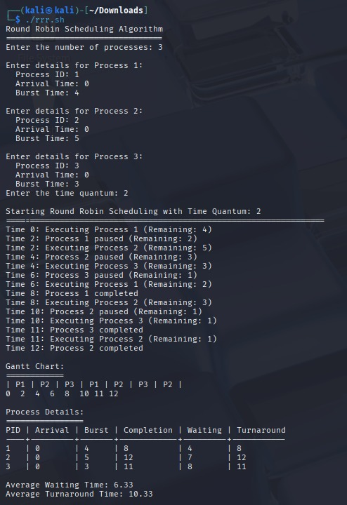

**Experiment No: 9**

|  |
| --- |
| **Student Name and Roll Number: Nishant Rajora 23csu220** |
| **Semester /Section: 5th DS-A** |
| **Link to Code:** |
| **Date: 22/09/2025** |
| **Faculty Signature: Dr. Asha Sohal** |
| **Marks:** |

|  |
| --- |
| **Objective:** Write a program to implement reader/writer problem using semaphore |
| **Program Outcome**  The students will understand the reader/writer problem using semaphore |
| **Problem Statement:**  Write a program to implement reader/writer problem using semaphore |
| **Background Study:** There is a shared resource which should be accessed by multiple processes. There are two types of processes in this context. They are reader and writer. Any number of readers can read from the shared resource simultaneously, but only one writer can write to the shared resource. When a writer is writing data to the resource, no other process can access the resource. A writer cannot write to the resource if there are non-zero number of readers accessing the resource at that time. |
| **Question Bank:**   1. An un-interruptible unit is known as ____________ a) single **b) atomic** c) static d) none of the mentioned 2. TestAndSet instruction is executed ____________ a) after a particular process b) periodically **c) atomically** d) none of the mentioned 3. Semaphore is a/an _______ to solve the critical section problem. a) hardware for a system b) special program for a system **c) integer variable** d) none of the mentioned 4. What are the two atomic operations permissible on semaphores? a**) wait** b) stop c) hold d) none of the mentioned 5. When several processes access the same data concurrently and the outcome of the execution depends on the particular order in which the access takes place is called ________ a) dynamic condition **b) race condition** c) essential condition d) critical condition |

**Student Work Area**

**Algorithm/Flowchart/Code/Sample Outputs**

#!/bin/bash

# Shared resource

shared_data=0

# Mutex simulation using a lock file

lockfile="/tmp/reader_writer.lock"

# Create lock file if it doesn't exist

touch $lockfile

# Function for reader

reader() {

id=$1

for i in {1..5}; do

echo "Reader $id is waiting to read..."

sleep 1 # simulate waiting

# Acquire read lock (simulate using lock file)

exec 200>"$lockfile"

flock -s 200 # shared lock for readers

echo "Reader $id: read shared_data = $shared_data"

sleep 1 # simulate reading

flock -u 200 # release lock

sleep 1

done

}

# Function for writer

writer() {

id=$1

for i in {1..5}; do

echo "Writer $id is waiting to write..."

sleep 2 # simulate waiting

# Acquire write lock (exclusive)

exec 200>"$lockfile"

flock -x 200 # exclusive lock for writer

shared_data=$((shared_data + 1))

echo "Writer $id: wrote shared_data = $shared_data"

sleep 2 # simulate writing

flock -u 200 # release lock

sleep 1

done

}

# Start readers and writers in background

reader 1 &

reader 2 &

writer 1 &

reader 3 &

writer 2 &

# Wait for all background processes to finish

wait

echo "Simulation complete. Final shared_data = $shared_data"

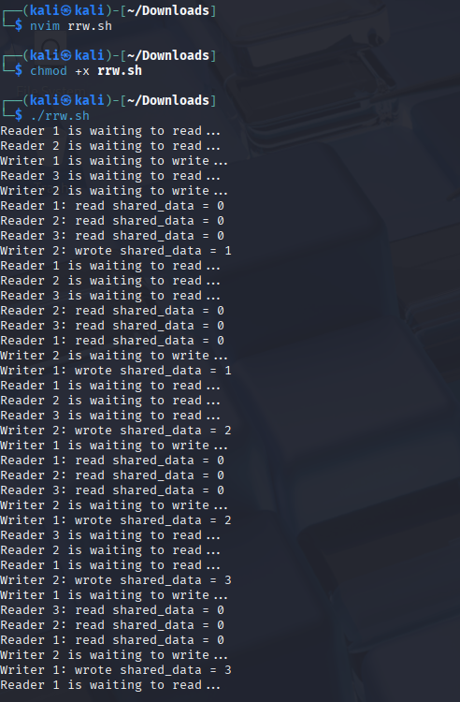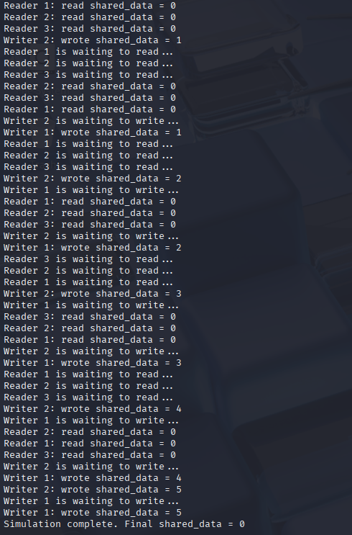

**Experiment No: 10**

|  |
| --- |
| **Student Name and Roll Number: Nishant Rajora 23csu220** |
| **Semester /Section: 5th DS-A** |
| **Link to Code:** |
| **Date: 06/10/2025** |
| **Faculty Signature: Dr. Asha Sohal** |
| **Marks:** |

|  |
| --- |
| **Objective:**  Write a program to implement Dining Philosopher’s problem using semaphore |
| **Outcome:**  The students will understand the problem of synchronization among processes and its solution through Dining Philosopher’s problem using semaphore |
| **Problem Statement:**  Write a program to implement Dining Philosopher’s problem using semaphore |
| **Background Study:**  Five philosophers, spend their time thinking and eating spaghetti. They eat at a round table with five individual seats. For eating each philosopher needs two forks (the resources). There are five forks on the table, one left and one right of each seat. When a philosopher cannot grab both forks it sits and waits. Eating takes random time, then the philosopher puts the forks down and leaves the dining room. After spending some random time thinking he again becomes hungry, and the circle repeats itself. |
| **Question Bank:**   1. Which one of the following is a synchronization tool? a) thread b) pipe **c) semaphore** d) socket 2. A semaphore is a shared integer variable __________ **a) that can not drop below zero** b) that can not be more than zero c) that can not drop below one d) that can not be more than one 3. The bounded buffer problem is also known as ____________ a) Readers – Writers problem b) Dining – Philosophers problem **c) Producer – Consumer problem** d) None of the mentioned 4. In the bounded buffer problem ____________ a) there is only one buffer **b) there are n buffers ( n being greater than one but finite)** c) there are infinite buffers d) the buffer size is bounded 5. To ensure difficulties do not arise in the readers – writers problem _______ are given exclusive access to the shared object. a) readers **b) writers** c) readers and writers d) none of the mentioned |

**Student Work Area**

**Algorithm/Flowchart/Code/Sample Outputs**

#!/bin/bash

# Dining Philosopher Problem using Semaphore (flock)

# With Gantt Chart Display

clear

echo "===== Dining Philosopher’s Problem Simulation ====="

echo "Total Philosophers: 5"

echo "Each philosopher will eat 3 times."

echo "----------------------------------------------------"

NUM_PHIL=5

declare -a gantt_chart

# Create fork locks as temporary files

for ((i=0; i<NUM_PHIL; i++))

do

touch fork_$i.lock

exec {fd[i]}<>fork_$i.lock

done

# Function for each philosopher

philosopher() {

id=$1

left=$id

right=$(( (id + 1) % NUM_PHIL ))

eat_count=0

while [ $eat_count -lt 3 ]

do

echo "Philosopher $id is THINKING 🧠"

gantt_chart+=("P$id:Thinking")

sleep $((RANDOM % 2 + 1))

echo "Philosopher $id is HUNGRY 😋"

gantt_chart+=("P$id:Hungry")

# Lock both forks (critical section)

if [ $id -eq $((NUM_PHIL - 1)) ]; then

# To prevent deadlock, last philosopher picks right fork first

flock -x ${fd[$right]}

flock -x ${fd[$left]}

else

flock -x ${fd[$left]}

flock -x ${fd[$right]}

fi

echo "Philosopher $id is EATING 🍝"

gantt_chart+=("P$id:Eating")

sleep $((RANDOM % 2 + 1))

# Unlock forks

flock -u ${fd[$left]}

flock -u ${fd[$right]}

echo "Philosopher $id finished eating and put down forks 🍴"

((eat_count++))

done

echo "Philosopher $id has left the table ✅"

}

# Start all philosophers simultaneously

for ((i=0; i<NUM_PHIL; i++))

do

philosopher $i &

done

# Wait for all philosophers to finish

wait

# Display Gantt Chart

echo -e "\n=========== GANTT CHART ==========="

timeline=""

for event in "${gantt_chart[@]}"

do

timeline+="$event | "

done

echo "$timeline"

echo "==================================="

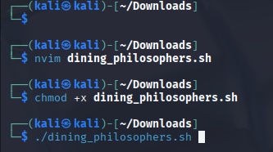

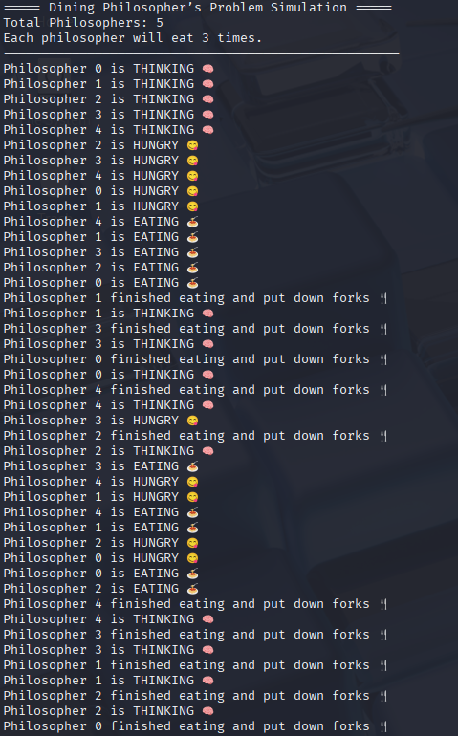

**Experiment No:11**

|  |
| --- |
| **Student Name and Roll Number: Nishant Rajora 23csu220** |
| **Semester /Section: 5th DS-A** |
| **Link to Code:** |
| **Date: 11/09/2025** |
| **Faculty Signature: Dr. Asha Sohal** |
| **Marks:** |

|  |
| --- |
| **Objective:**  Write a program to implement Banker’s algorithm for deadlock avoidance. |
| **Outcome:**  The students will understand how system handles deadlock using Banker’s algorithm for deadlock avoidance |
| **Problem Statement:**  Write a program to implement Banker’s algorithm for deadlock avoidance. |
| **Background Study:**  The banker’s algorithm is a resource allocation and deadlock avoidance algorithm that tests for safety by simulating the allocation for predetermined maximum possible amounts of all resources, then makes an “s-state” check to test for possible activities, before deciding whether allocation should be allowed to continue. Banker’s algorithm is named so because it is used in banking system to check whether loan can be sanctioned to a person or not. Suppose there are n number of account holders in a bank and the total sum of their money is S. If a person applies for a loan then the bank first subtracts the loan amount from the total money that bank has and if the remaining amount is greater than S then only the loan is sanctioned. It is done because if all the account holders comes to withdraw their money then the bank can easily do it. |
| **Question Bank:**   1. Each request requires that the system consider the _____________ to decide whether the current request can be satisfied or must wait to avoid a future possible deadlock. **a) resources currently available** b) processes that have previously been in the system c) resources currently allocated to each process d) future requests and releases of each process 2. Given a priori information about the ________ number of resources of each type that maybe requested for each process, it is possible to construct an algorithm that ensures that the system will never enter a deadlock state. a) minimum b) average **c) maximum** d) approximate 3. A deadlock avoidance algorithm dynamically examines the __________ to ensure that a circular wait condition can never exist. **a) resource allocation state** b) system storage state c) operating system d) resources 4. A state is safe, if ____________ a) the system does not crash due to deadlock occurrence **b) the system can allocate resources to each process in some order and still avoid a deadlock** c) the state keeps the system protected and safe d) all of the mentioned 5. The two ways of aborting processes and eliminating deadlocks are ____________ a) Abort all deadlocked processes b) Abort all processes c) Abort one process at a time until the deadlock cycle is eliminated **d) All of the mentioned** |

**Student Work Area**

**Algorithm/Flowchart/Code/Sample Outputs**

#!/bin/sh

# Banker's Algorithm in Shell (dash compatible)

echo "Enter number of processes: "

read n

echo "Enter number of resources: "

read m

# Read Allocation Matrix

echo "Enter Allocation Matrix (each row on new line, space separated):"

i=0

while [ $i -lt $n ]

do

read row

alloc[$i]="$row"

i=$((i+1))

done

# Read Max Matrix

echo "Enter Max Matrix (each row on new line, space separated):"

i=0

while [ $i -lt $n ]

do

read row

max[$i]="$row"

i=$((i+1))

done

# Read Available

echo "Enter Available Resources (space separated):"

read avail

# Compute Need Matrix

echo "\nNeed Matrix:"

i=0

while [ $i -lt $n ]

do

need=""

j=1

for a in ${alloc[$i]}; do

maxj=$(echo ${max[$i]} | cut -d' ' -f$j)

needval=$((maxj - a))

need="$need $needval"

j=$((j+1))

done

need_matrix[$i]="$need"

echo "$need"

i=$((i+1))

done

# Safety Algorithm

finish=""

seq=""

for k in $(seq 0 $((n-1))); do finish="$finish 0"; done

work="$avail"

count=0

while [ $count -lt $n ]

do

found=0

i=0

for row in "${need_matrix[@]}"

do

fi=$(echo $finish | cut -d' ' -f$((i+1)))

if [ $fi -eq 0 ]; then

ok=1

j=1

for needj in $row; do

workj=$(echo $work | cut -d' ' -f$j)

if [ $needj -gt $workj ]; then

ok=0

break

fi

j=$((j+1))

done

if [ $ok -eq 1 ]; then

# Allocate

j=1

newwork=""

for allocj in ${alloc[$i]}; do

workj=$(echo $work | cut -d' ' -f$j)

newwork="$newwork $((workj + allocj))"

j=$((j+1))

done

work="$newwork"

finish=$(echo $finish | awk -v pos=$((i+1)) '{for(k=1;k<=NF;k++){if(k==pos) printf "1 "; else printf $k" "} }')

seq="$seq P$i"

count=$((count+1))

found=1

break

fi

fi

i=$((i+1))

done

if [ $found -eq 0 ]; then

echo "\n❌ System is in UNSAFE state!"

exit 1

fi

done

echo "\n✅ System is in SAFE state"

echo "Safe Sequence: $seq"

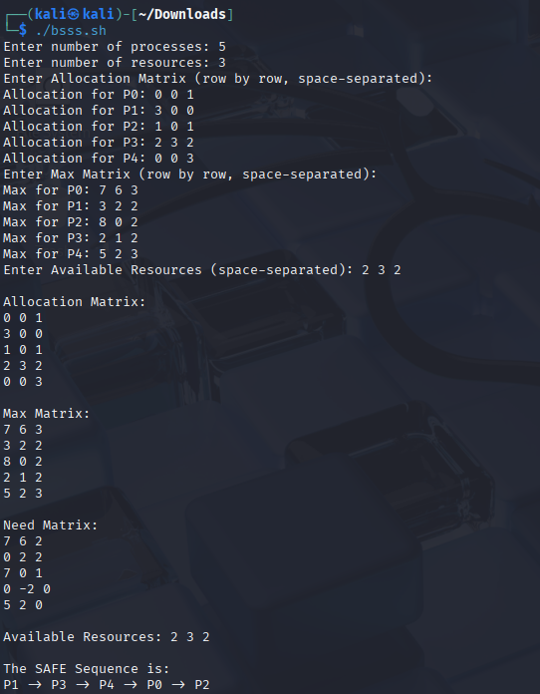

**Experiment No: 12**

|  |
| --- |
| **Student Name and Roll Number: Nishant Rajora 23csu220** |
| **Semester /Section: 5th DS-A** |
| **Link to Code:** |
| **Date: 03/11/2025** |
| **Faculty Signature: Dr. Asha Sohal** |
| **Marks:** |

|  |
| --- |
| **Objective:**  Write a program for page replacement policy using a) LRU b) FIFO c) Optimal. |
| **Outcome:**  The students will understand concept of memory management through various page replacement policy using a) LRU b) FIFO |
| **Problem Statement:**  Write a program to implement page replacement policy using a) LRU b) FIFO c) Optimal. |
| **Background Study:**  In operating systems that use paging for memory management, page replacement algorithm are needed to decide which page needed to be replaced when new page comes in. Whenever a new page is referred and not present in memory, page fault occurs and Operating System replaces one of the existing pages with newly needed page. Different page replacement algorithms suggest different ways to decide which page to replace. The target for all algorithms is to reduce number of page faults. |
| **Question Bank:**  1. The main memory accommodates ____________ a) operating system b) cpu c) user processes **d) all of the mentioned**  2. What is the operating system? a) in the low memory b) in the high memory **c) either low or high memory (depending on the location of interrupt vector)** d) none of the mentioned  3. In contiguous memory allocation ____________ **a) each process is contained in a single contiguous section of memory** b) all processes are contained in a single contiguous section of memory c) the memory space is contiguous d) none of the mentioned  4. The relocation register helps in ____________ a) providing more address space to processes **b) a different address space to processes** c) to protect the address spaces of processes d) none of the mentioned  5. With relocation and limit registers, each logical address must be _______ the limit register. **a) less than** b) equal to c) greater than d) none of the mentioned |

**Student Work Area**

**Algorithm/Flowchart/Code/Sample Outputs**

#!/bin/bash

echo "Enter number of frames:"

read f

echo "Enter number of pages:"

read n

echo "Enter the page reference string (space separated):"

read -a pages

# ---------- FIFO ----------

echo -e "\n=== FIFO Page Replacement ==="

frames=()

faults=0

index=0

for ((i=0; i<n; i++))

do

page=${pages[i]}

if [[ ! " ${frames[@]} " =~ " $page " ]]; then

if [ ${#frames[@]} -lt $f ]; then

frames+=($page)

else

frames[$index]=$page

index=$(( (index+1) % f ))

fi

faults=$((faults+1))

fi

echo "Frames: ${frames[@]}"

done

echo "Total Page Faults (FIFO): $faults"

# ---------- LRU ----------

echo -e "\n=== LRU Page Replacement ==="

frames=()

faults=0

declare -a recent

for ((i=0; i<n; i++))

do

page=${pages[i]}

if [[ " ${frames[@]} " =~ " $page " ]]; then

recent[$page]=$i # update recent use

else

if [ ${#frames[@]} -lt $f ]; then

frames+=($page)

recent[$page]=$i

else

# find least recently used

lru_index=0

min=${recent[${frames[0]}]}

for ((j=1; j<f; j++))

do

if [ ${recent[${frames[j]}]} -lt $min ]; then

min=${recent[${frames[j]}]}

lru_index=$j

fi

done

frames[$lru_index]=$page

recent[$page]=$i

fi

faults=$((faults+1))

fi

echo "Frames: ${frames[@]}"

done

echo "Total Page Faults (LRU): $faults"

# ---------- OPTIMAL ----------

echo -e "\n=== OPTIMAL Page Replacement ==="

frames=()

faults=0

for ((i=0; i<n; i++))

do

page=${pages[i]}

if [[ " ${frames[@]} " =~ " $page " ]]; then

true

else

if [ ${#frames[@]} -lt $f ]; then

frames+=($page)

else

farthest=-1

replace_index=-1

for ((j=0; j<f; j++))

do

k=$((i+1))

while [ $k -lt $n ] && [ ${frames[j]} -ne ${pages[k]} ]; do

((k++))

done

if [ $k -gt $farthest ]; then

farthest=$k

replace_index=$j

fi

done

frames[$replace_index]=$page

fi

faults=$((faults+1))

fi

echo "Frames: ${frames[@]}"

done

echo "Total Page Faults (OPTIMAL): $faults"

